**/describe**

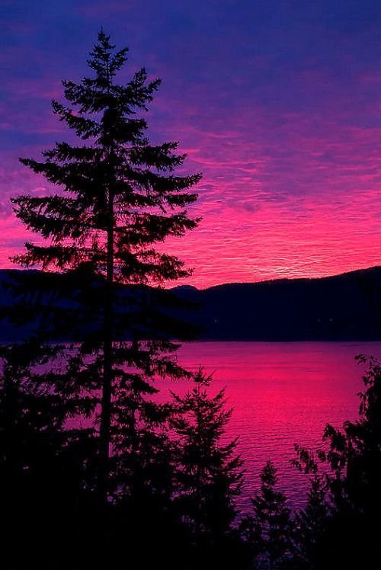

1️⃣ a pink purple sunset surrounded by pine trees and water with red mountains, in the style of flickr, vancouver school, windows xp, joyful celebration of nature, i can't believe how beautiful this is, eye-catching, dark pink and aquamarine --ar 2:3

2️⃣ a pink and purple sky is seen over a body of water, in the style of the vancouver school, flickr, joyful celebration of nature, romantic: dramatic landscapes, charles ginner, red and purple, naturecore --ar 2:3

3️⃣ photograph bc sunrise by jamie yr, in the style of kodak aerochrome, naturecore, romanticized views, emphasis on nature, violet and magenta, flickr, cabincore --ar 2:3

4️⃣ i dipped my tooth into the water at the sunrise, which was the light of our dreams, in the style of dark pink and violet, the vancouver school, romanticized nature, flickr, nature-based patterns, windows xp, romantic scenery --ar 2:3

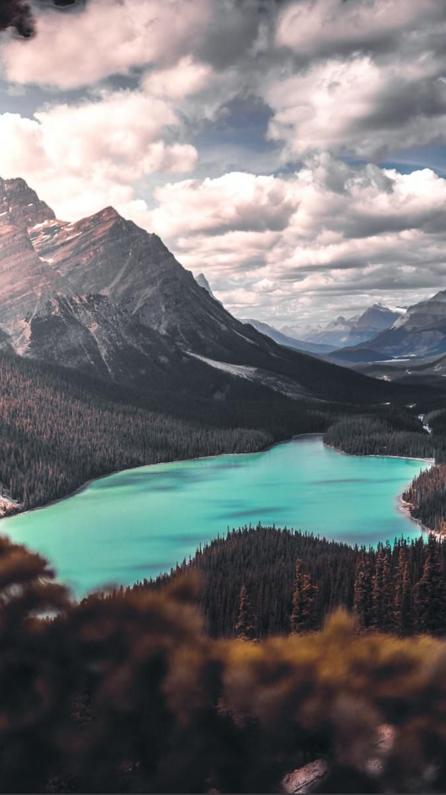

1️⃣ banff national park turquoise lake under cloudy sky, in the style of post-apocalyptic backdrops, uhd image, 3840x2160, nature-inspired motifs, birds-eye-view, creative commons attribution, dark violet and dark green --ar 14:25

2️⃣ a lake or mountain is shown in the foreground, in the style of dark turquoise and light turquoise, vintage aesthetics, y2k aesthetic, hikecore, joel robison, nature inspired, violet and emerald --ar 14:25

3️⃣ banff national park park dj ae, in the style of turquoise and cyan, natural symbolism, poetic landscapes, hikecore, joel robison, light purple and dark amber, environmental awareness --ar 14:25

4️⃣ the kahkia a mountain lake in nature by the viewfinder of a tree and mountains, in the style of light turquoise and dark emerald, y2k aesthetic, hikecore, sparse backgrounds, light purple and turquoise, vancouver school, 8k resolution --ar 14:25

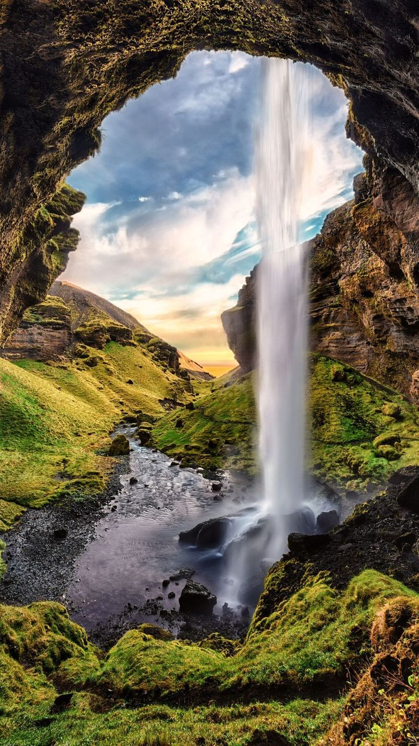

1️⃣ a waterfall outside of a cave inside the iceland iceland, in the style of pixelated landscapes, serene landscapism --ar 92:163

2️⃣ waterfall in iceland, in the style of nature-inspired imagery, pixelated landscapes --ar 92:163

3️⃣ waterfall iceland, iceland, waterfall, in the style of pixelated landscapes, light amber and green, serene and peaceful ambiance, 32k uhd, vik muniz, caras ionut, imposing monumentality --ar 92:163

4️⃣ a waterfall coming out of a cave inside iceland photo, in the style of pixelated landscapes, expansive landscapes --ar 92:163

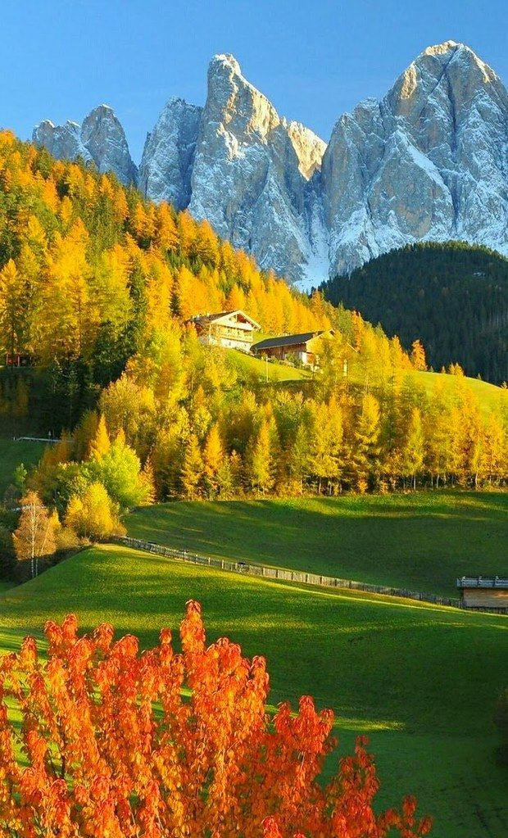

1️⃣ autumn and snow in the alps, in the style of yellow and emerald, earthy elegance, monsù desiderio, grandiose color schemes, maximilian pirner, use of bright colors, precise and sharp --ar 77:127

2️⃣ the trees are red, yellow and orange, in the style of italian landscapes, cabincore, yellow and emerald, precise and sharp, swiss style, whistlerian, landscape inspirations --ar 77:127

3️⃣ autumn leaves in a field, in the style of mountainous vistas, cabincore, yellow and emerald, swiss style, eye-catching, villagecore, pristine naturalism --ar 77:127

4️⃣ mountain range in the background, in the style of yellow and emerald, cottagecore --ar 77:127

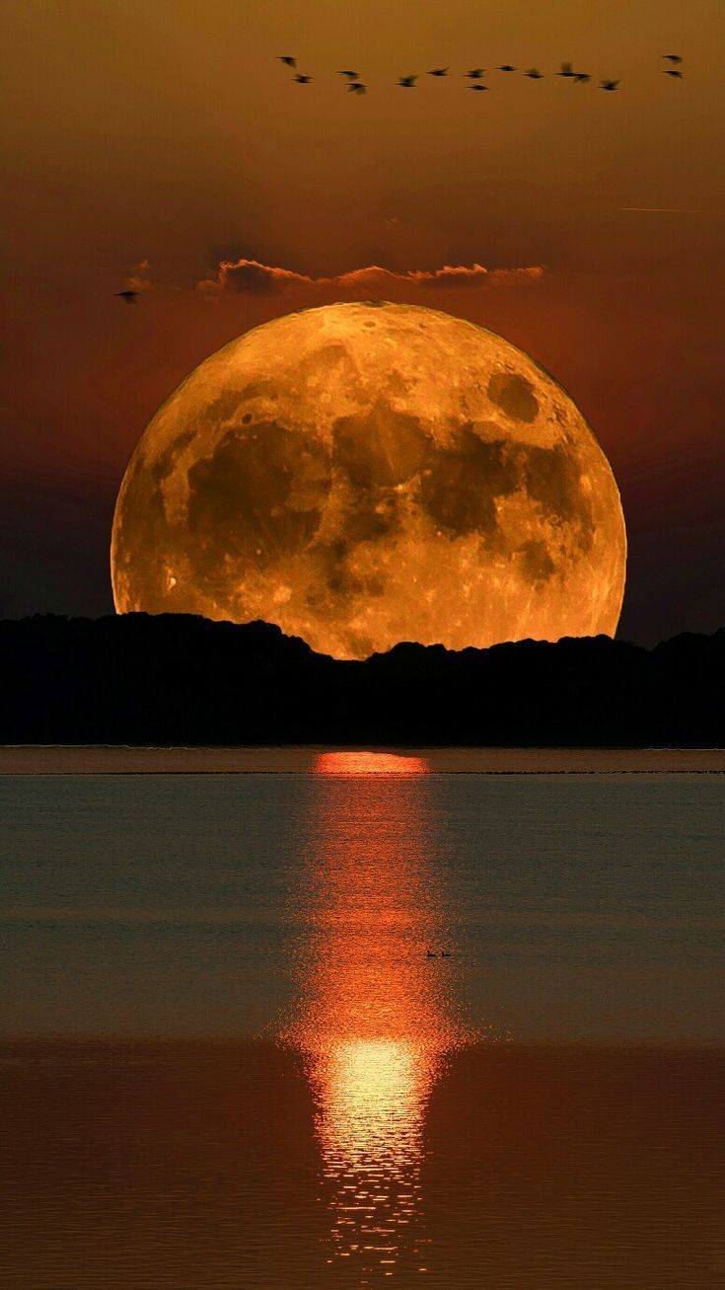

1️⃣ the full moon rising over a lake, in the style of dark orange and light gold, gigantic scale, flickr, photographic source, magewave, bombacore, eye-catching --ar 91:163

2️⃣ a full moon rising over lake at sunset, in the style of dark yellow and dark orange, gigantic scale, flickr, misha gordin, elaborate spacecrafts, magewave, associated press photo --ar 91:163

3️⃣ a full moon sets over the water and birds fly onto it, in the style of dark orange and light amber, gigantic scale, sleek, luminous colors, dark gold, long lens, luminescent installations --ar 91:163

4️⃣ full moon with bird's flying over water, in the style of dark orange and light gold, gigantic scale, misha gordin, flickr, 32k uhd, national geographic photo, alien worlds --ar 91:163

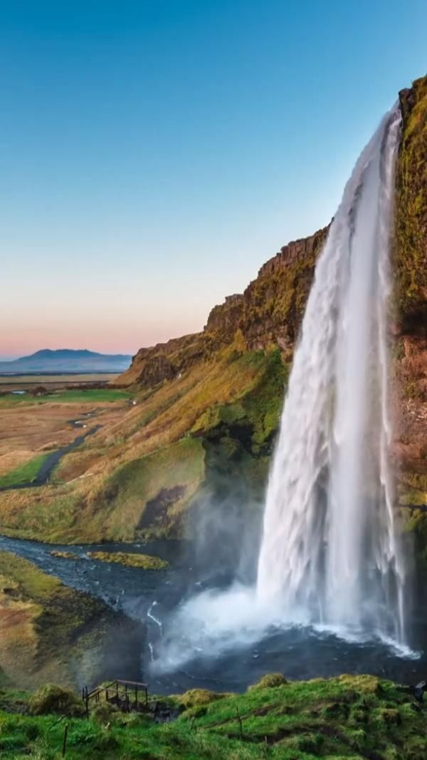

1️⃣ travel in iceland iran waterfalls, iceland tour packages, in the style of fleeting moments, wetcore --ar 75:133

2️⃣ the iceland waterfall at sunset, in the style of iconic imagery, wetcore, iconic --ar 75:133

3️⃣ waterfall at sunset in iceland, in the style of iconic imagery, 500–1000 ce, wetcore, exacting precision, environmental awareness --ar 75:133

4️⃣ a waterfall with beautiful water falls down in the middle of a green grove of grass, in the style of iconic imagery, kimoicore, light sky-blue and light amber, raw metallicity, studyblr, 500–1000 ce, expansive landscapes --ar 75:133

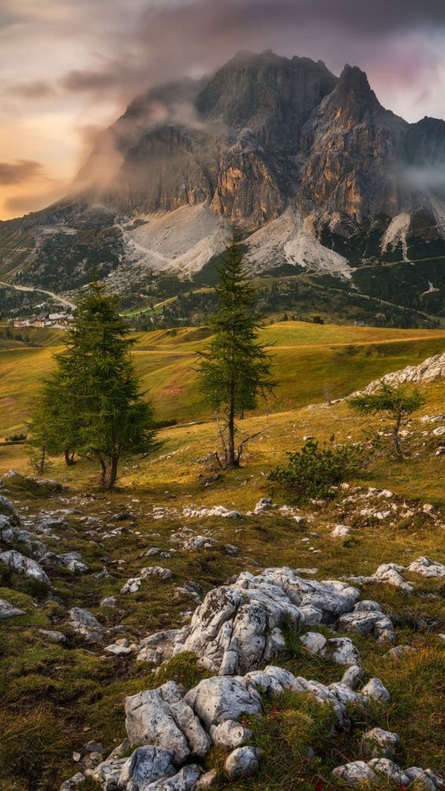

1️⃣ landscape with pine trees and mountains at sunset around the dolomites by julian bosniak, in the style of photo-realistic landscapes, dark beige and green, light amber and green, photo taken with provia, emilio giuseppe dossena, landscape inspirations, caras ionut --ar 14:25

2️⃣ sunset over rocky terrain in the dolomites of the alps, in the style of photo-realistic landscapes, forestpunk, rural landscapes --ar 14:25

3️⃣ landscape at sunset over mountains in a dolomite plateau, in the style of photo-realistic landscapes, schlieren photography --ar 14:25

4️⃣ a mountain with green grass and trees, in the style of dimitry roulland, nikon d850, jacopo bassano, light amber, quadratura, rimel neffati, traditional --ar 14:25

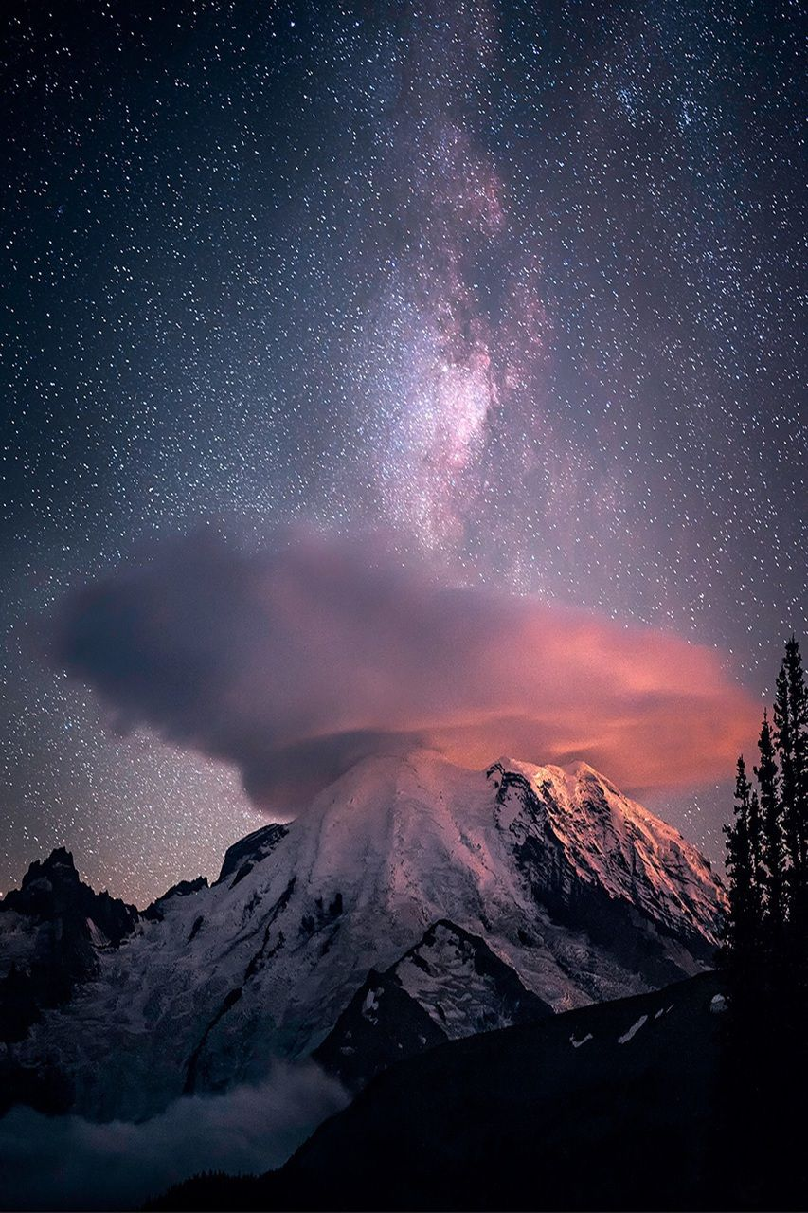

1️⃣ starry night over mount rainier northwest, in the style of captivating documentary photos, surrealistic dream-like imagery, surreal dream-like imagery, nebulous forms --ar 53:80

2️⃣ the mountain is lit up at night with a starry sky, in the style of michael eastman, dimitry roulland, bob ross, surrealistic dream-like imagery, light red and white, associated press photo, whistlerian --ar 53:80

3️⃣ mike hauge, storms of mountain highalp, rainier county, washington, in the style of the stars art group (xing xing), precisionism, captivating documentary photos, cosmic visions, evgeni gordiets, jeremy geddes, light pink and red --ar 53:80

4️⃣ a storm passes over a mountain in a dark sky, in the style of the stars art group (xing xing), dreamy portraits, whistlerian, associated press photo, light pink and red, exaggerated features, organic formations --ar 53:80

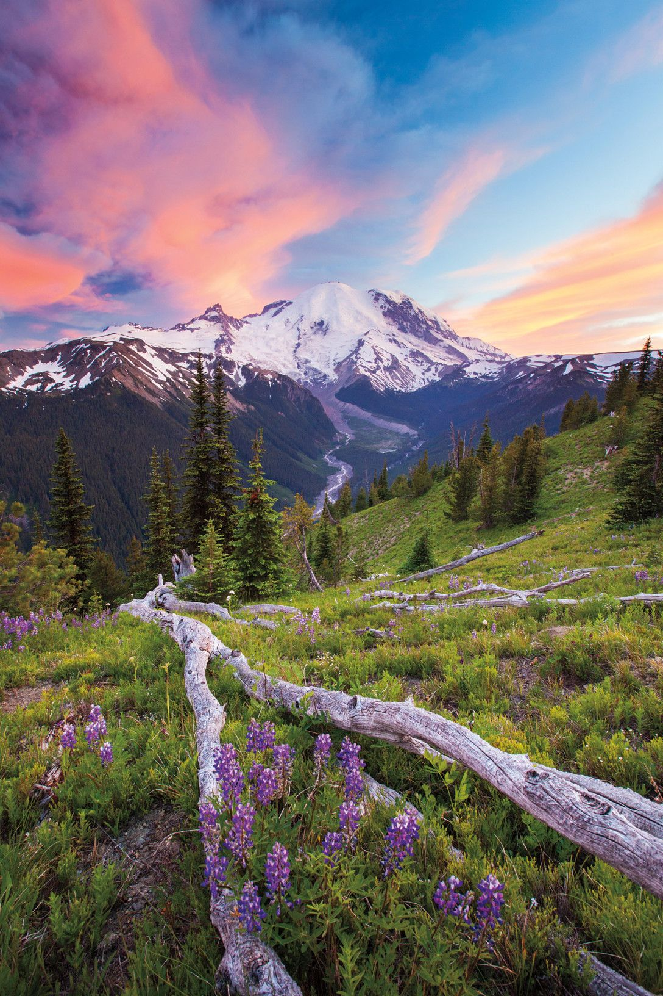

1️⃣ an untouched piece of natural landscape, in the style of vibrant hues master, precisionist, nature-inspired imagery, whistlerian, violet and pink, associated press photo, traditional craftsmanship --ar 2:3

2️⃣ a mountain with mountains behind it, in the style of vibrant landscapes, floralpunk, violet and brown, washington color school, national geographic photo, spectacular backdrops, romantic riverscapes --ar 2:3

3️⃣ fir trees around grassy hillsides, in the style of richly colored skies, intricate floral arrangements, national geographic photo, whistlerian, captures the essence of nature, vibrant landscapes, mountainous vistas --ar 2:3

4️⃣ the tree leaves on the ground, in the style of mountainous vistas, purple and emerald, whistlerian, captures the essence of nature, snapshots of america, floral explosions, impressive panoramas --ar 2:3

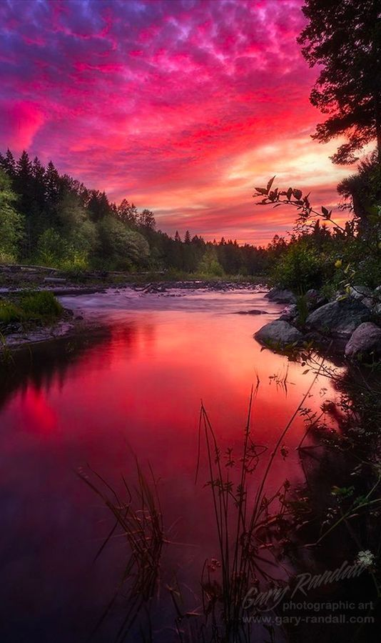

1️⃣ the red and pink sun setting over a river, in the style of natural symbolism, lush colors --ar 33:56

2️⃣ sunset over a river near trees, in the style of red and magenta, mesmerizing colorscapes, the snapshot aesthetic, whistlerian --ar 33:56

3️⃣ sunset over the meadowbrook river in sagago county, colorado by ogf photography, in the style of light crimson and magenta, contest winner, elihu vedder, norwegian nature, uhd image, andreas achenbach, emotional naturalism --ar 33:56

4️⃣ sunset over a pond and mountain, in the style of red and magenta, photo-realistic landscapes, swirling vortexes, windows xp --ar 33:56

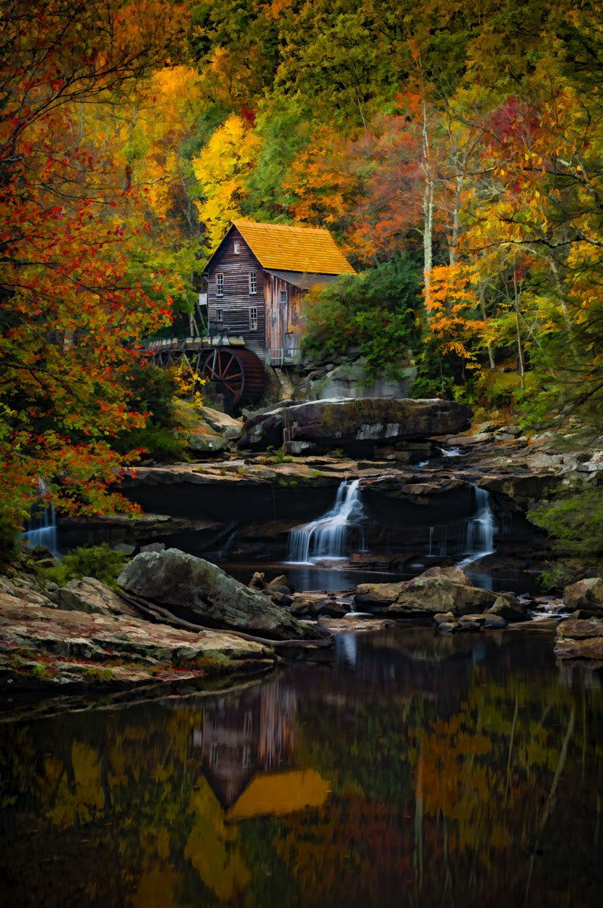

1️⃣ an old reformed stone mill and waterfall in the forest, in the style of erik jones, dark white and amber, mike campau, vibrant coloration, burt glinn, fine art photography, colorful landscapes --ar 33:50

2️⃣ a fall scene with water flowing in the background, in the style of old-world charm, grandiose color schemes, cabincore, uhd image, pictorial storytelling, industrialization, bold primary colors --ar 33:50

3️⃣ a yellow house in the forest with autumn leaves, in the style of mitch griffiths, romantic riverscapes, photographic source, david nordahl, industrialization, dark white and orange, national geographic photo --ar 33:50

4️⃣ a country house sits among a small stream, in the style of dramatic colors, new american color photography, samyang af 14mm f/2.8 rf, industrialization, detailed foliage, romantic: dramatic landscapes, whirly --ar 33:50

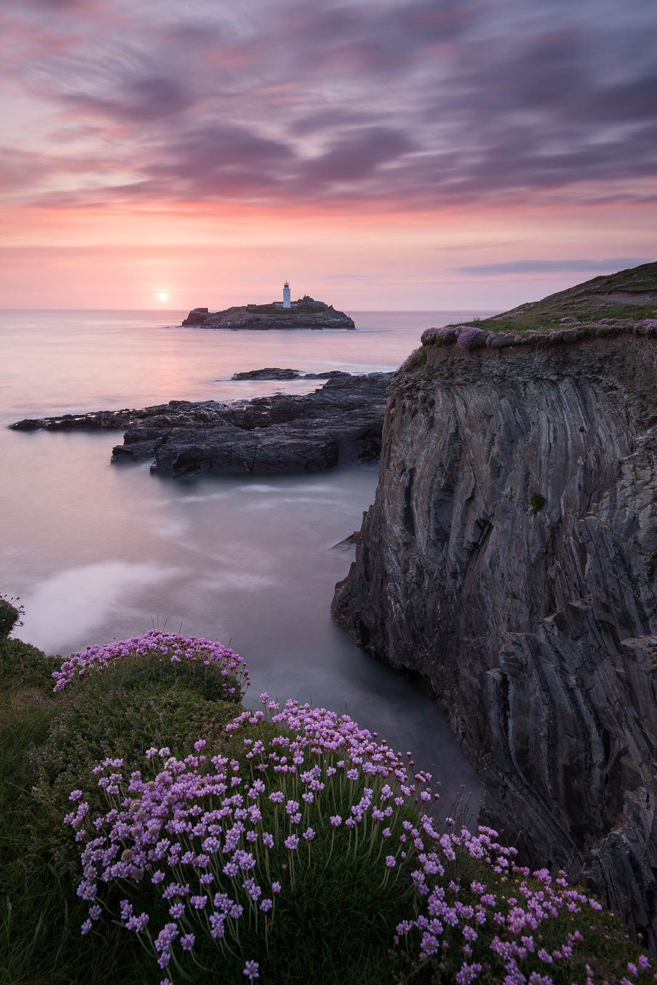

1️⃣ cliffs surrounded by a lighthouse and flowers, in the style of michael shainblum, light magenta and bronze, ian howorth, iso 200, light purple and bronze, delicate landscapes, rim light --ar 133:200

2️⃣ a sunset over rocky shores with flowers along the shore, in the style of light magenta and bronze, large format lens, mallgoth, whimsical settings, delicately detailed, bold landscapes, rim light --ar 133:200

3️⃣ images by julien lin 'beach time' on 500px, in the style of light magenta and bronze, traditional british landscapes, rodenstock imagon 300mm f/5.8, metropolis meets nature, sony alpha a7 iii, whimsical floral scenes, light bronze and gray --ar 133:200

4️⃣ new years eve sunrise by julie otti, in the style of light magenta and bronze, coastal landscapes, sony fe 12-24mm f/2.8 gm, whimsical floral scenes, charles spencelayh, serge marshennikov, isolated landscapes --ar 133:200

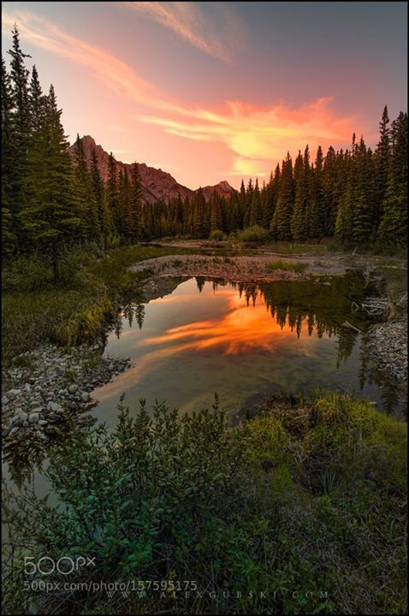

1️⃣ a sunset over a pond in forest, in the style of whistlerian, mesmerizing optical illusions, photo-realistic landscapes --ar 59:90

2️⃣ sunset sky over a lake in the mountains, in the style of associated press photo, whistlerian, i can't believe how beautiful this is, secluded settings, red and green, national geographic photo, unreal engine --ar 59:90

3️⃣ the sun was about to set on the water in the valley, in the style of donald pass, natural symbolism, national geographic photo, windows xp, stephen shortridge, red and green, i can't believe how beautiful this is --ar 59:90

4️⃣ photo by alexis philips on 500px, in the style of luminous reflections, donald pass, light red and bronze, flickr, jeff danziger, arcadian landscapes, stephen shortridge --ar 59:90

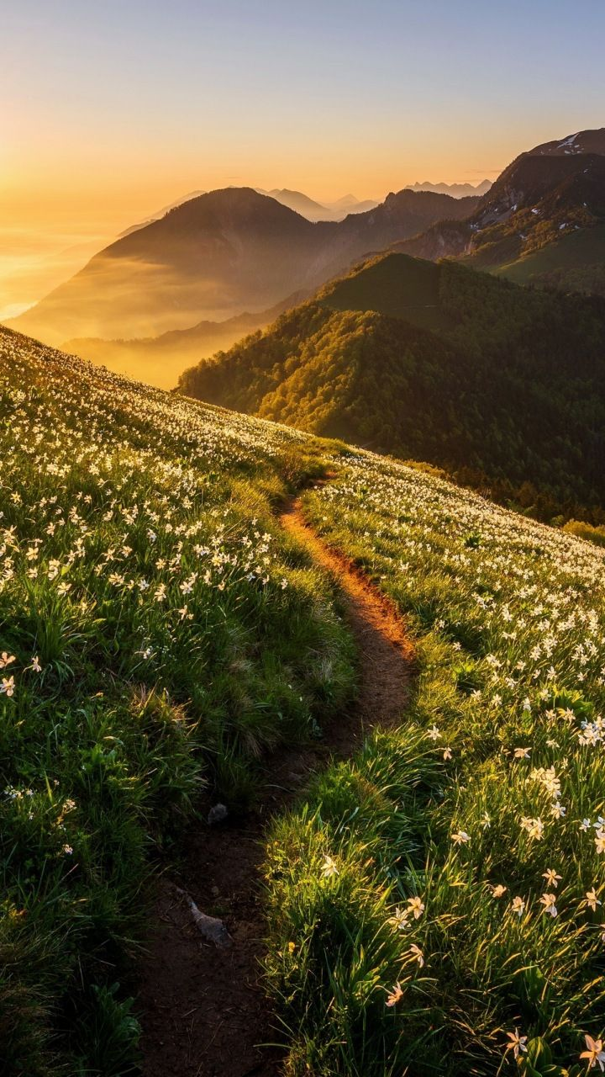

1️⃣ trail at sun rise in the meadows with white daisies, in the style of filip hodas, mountainous vistas, ildiko neer, 8k, the aesthetic movement, captivating light, charismatic --ar 9:16

2️⃣ a trail near the mountains with lilacs and solitary daisy flowers, in the style of enchanting lighting, golden hues, white and green, nature-inspired imagery, agfa vista, ambitious, sustainable design --ar 9:16

3️⃣ sunny day with white flowers, mountains on an aspen field, in the style of filip hodas, max rive, tj drysdale, passage, inspirational, sunprint, fantastical street --ar 9:16

4️⃣ a path is going through the forest in the mountains, in the style of delicate flowers, light bronze and white, 32k uhd, landscape inspirations, national geographic photo, pastoral charm, golden light --ar 9:16

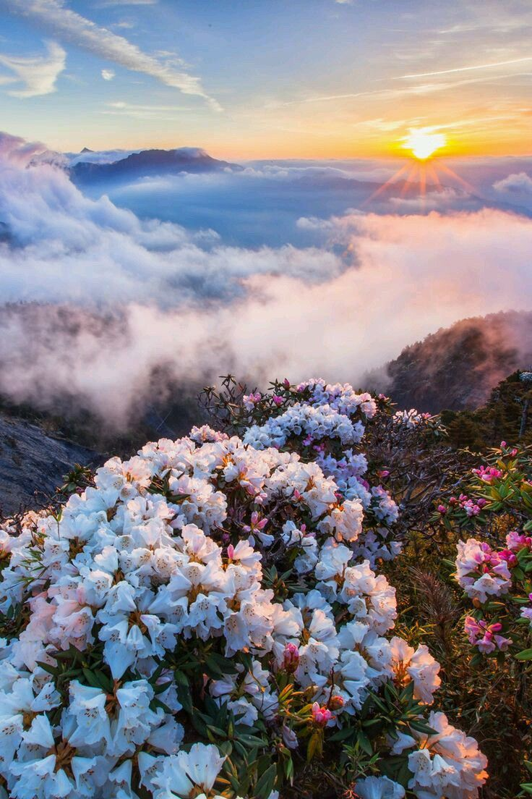

1️⃣ white flowers blooming on top of mountain at sunrise, in the style of light orange and light magenta, dao trong le, radiant clusters, joong keun lee, romantic scenery, the aesthetic movement, sky-blue and emerald --ar 2:3

2️⃣ flowers bloom on a mountain over the clouds, in the style of dao trong le, romantic emotivity, soft and dreamy --ar 2:3

3️⃣ sunrise over a mountain and flowers, in the style of ethereal images, ethereal cloudscapes --ar 2:3

4️⃣ white flowers and clouds are near a mountain in kerala, in the style of light magenta and light bronze, radiant clusters, magewave, sky-blue and orange, capturing moments, the san francisco renaissance. --ar 2:3

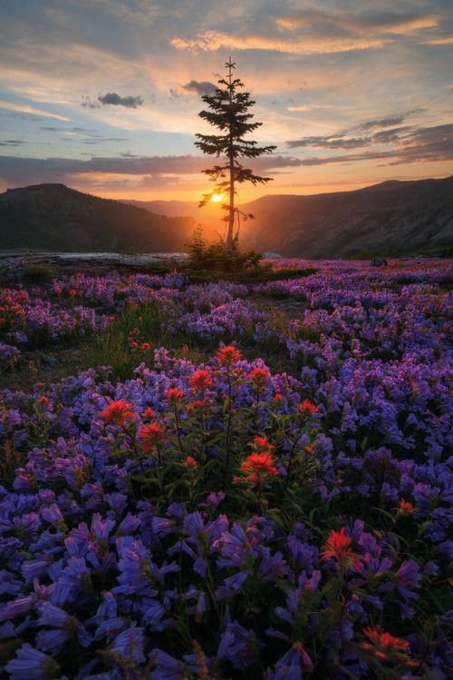

1️⃣ sunset over mountains and flowers, in the style of mesmerizing colorscapes, national geographic photo, whistlerian, david nordahl, i can't believe how beautiful this is, joyful celebration of nature, violet and orange --ar 2:3

2️⃣ sunrise over japanese purple flowers, in the style of whistlerian, bold and vibrant primary colors, intricately mapped worlds, romantic: dramatic landscapes --ar 2:3

3️⃣ beautiful, blue sunrise on flowering mountain, in the style of purple and orange, captivating documentary photos, national geographic photo, whistlerian, landscape mastery, whimsical floral scenes, light crimson and green --ar 2:3

4️⃣ a lone wild turkey and flowers in the field, at sunset, in the style of national geographic photo, whistlerian, landscape mastery, red and purple, rtx on, enchanting realms --ar 2:3

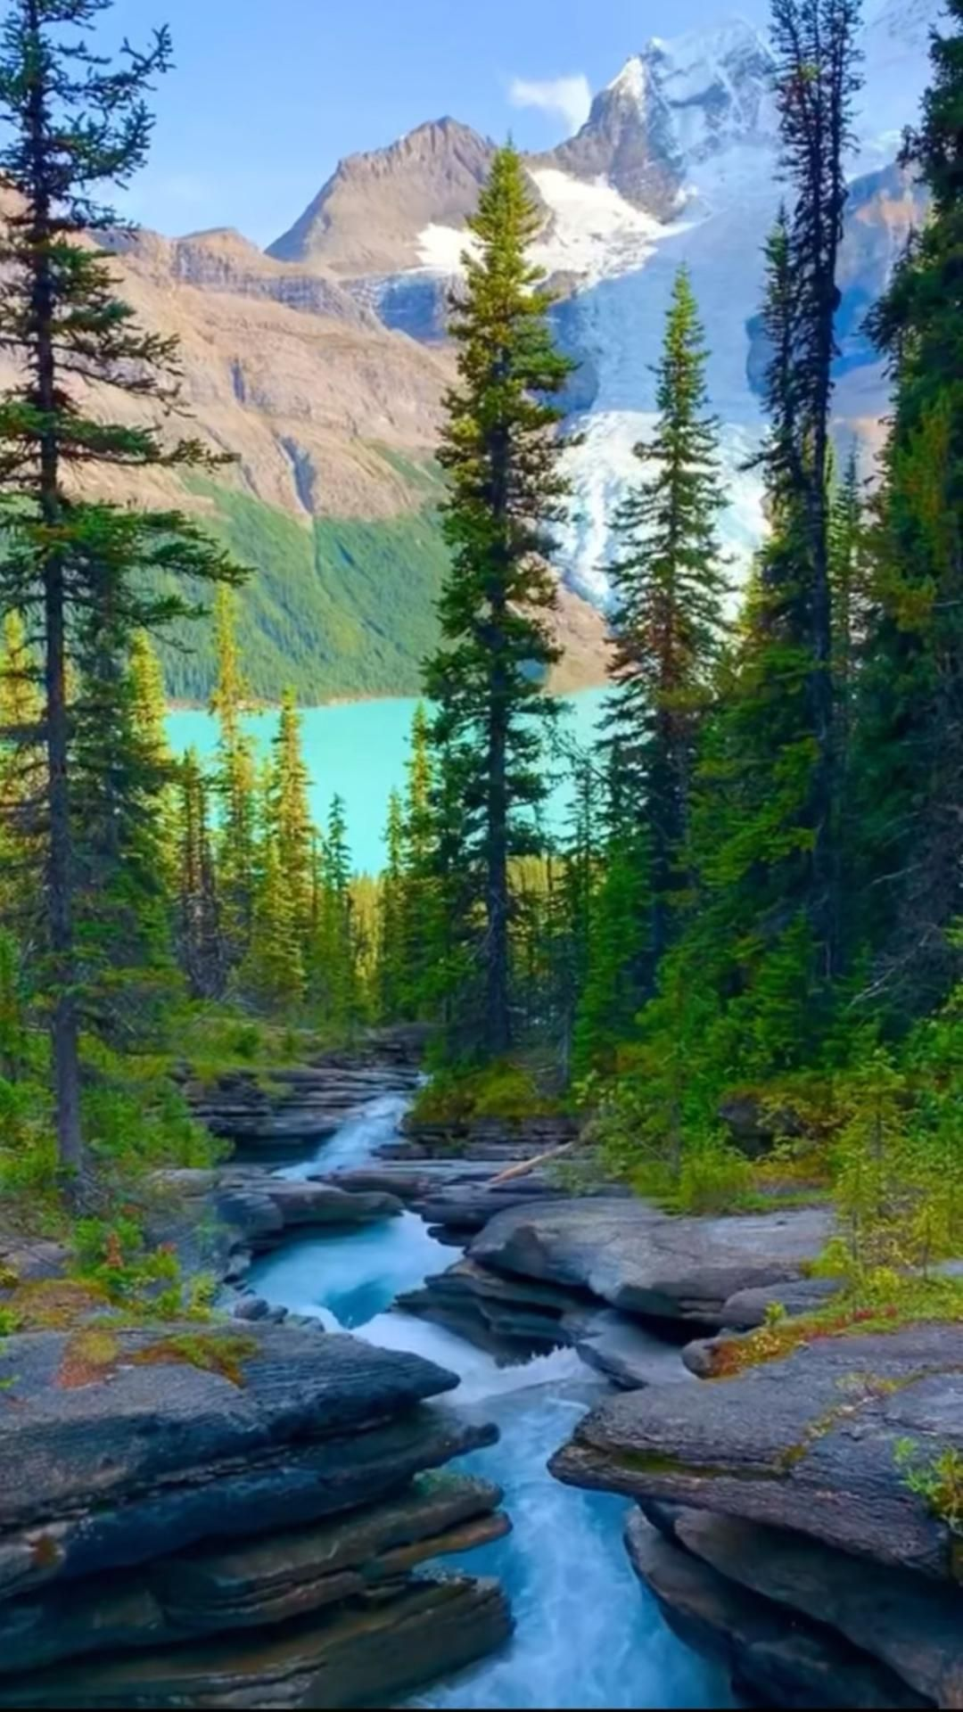

1️⃣ in canada, landscape scenery, scenery footage, bbc, canada, in the style of light aquamarine and emerald, rob hefferan, joyful celebration of nature, gutai group, forestpunk, fluid landscapes, wilderness --ar 9:16

2️⃣ a river and mountains surrounded by trees and a lake, in the style of 32k uhd, patrick brown, green and aquamarine, outdoor scenes, lively nature scenes, luminosity of water, video glitches --ar 9:16

3️⃣ the tidal river in the rocky mountains, in the style of video glitches, turquoise and emerald, 32k uhd, colorful woodcarvings, vancouver school, i can't believe how beautiful this is, rim light --ar 9:16

4️⃣ waterfall, mountain, fall foliage, in the style of 32k uhd, turquoise and emerald --ar 9:16

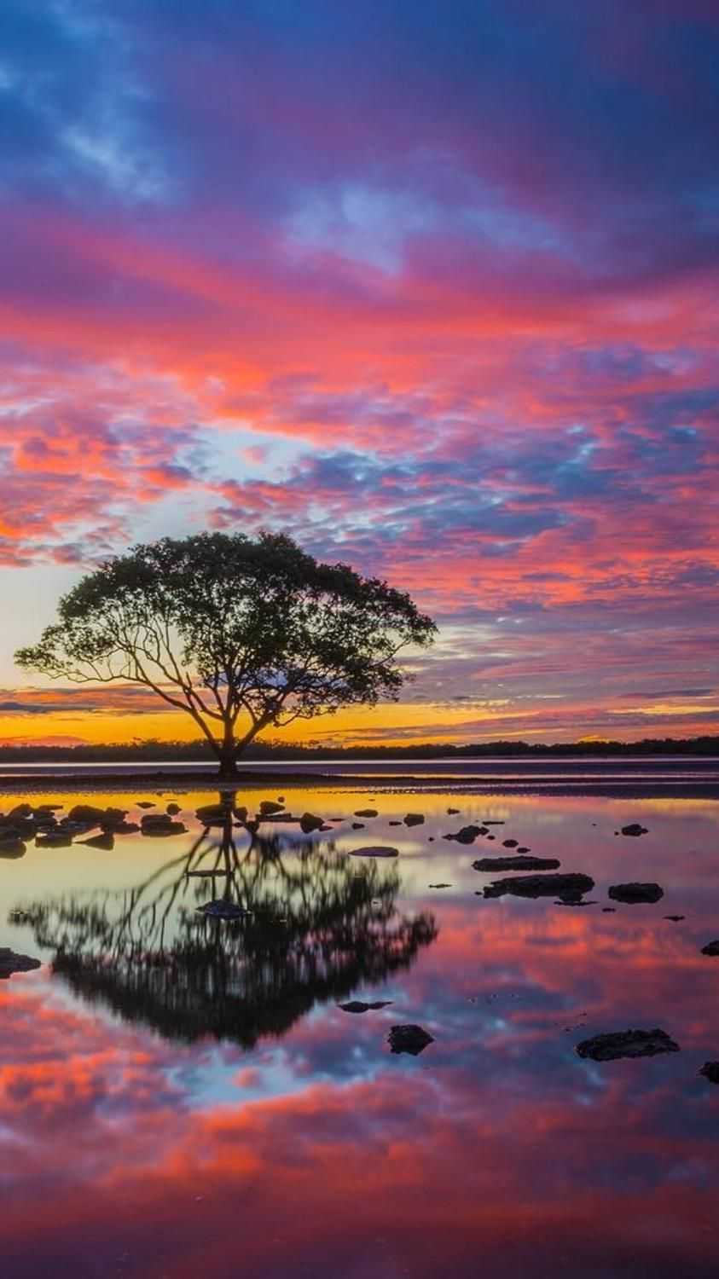

1️⃣ a lone tree is reflected on the surface of the water at sunset, in the style of sky-blue and magenta, art of tonga, 32k uhd, flickr, australian landscapes, lively nature scenes, vibrant stage backdrops --ar 105:187

2️⃣ a lone tree reflected in the lake after sunset, in the style of art of tonga, vibrant and lively hues, stanley pinker, 32k uhd, flickr, australian landscapes, god rays --ar 105:187

3️⃣ the color of the sky at sunset is seen in the water of the lagoon, in the style of australian landscapes, uhd image, flickr, art of tonga, ethereal trees, bold chromaticity, i can't believe how beautiful this is --ar 105:187

4️⃣ the tree reflected in the water is photographed, in the style of richly colored skies, art of tonga, stanley pinker, uhd image, australian landscapes, flickr, light violet and red --ar 105:187

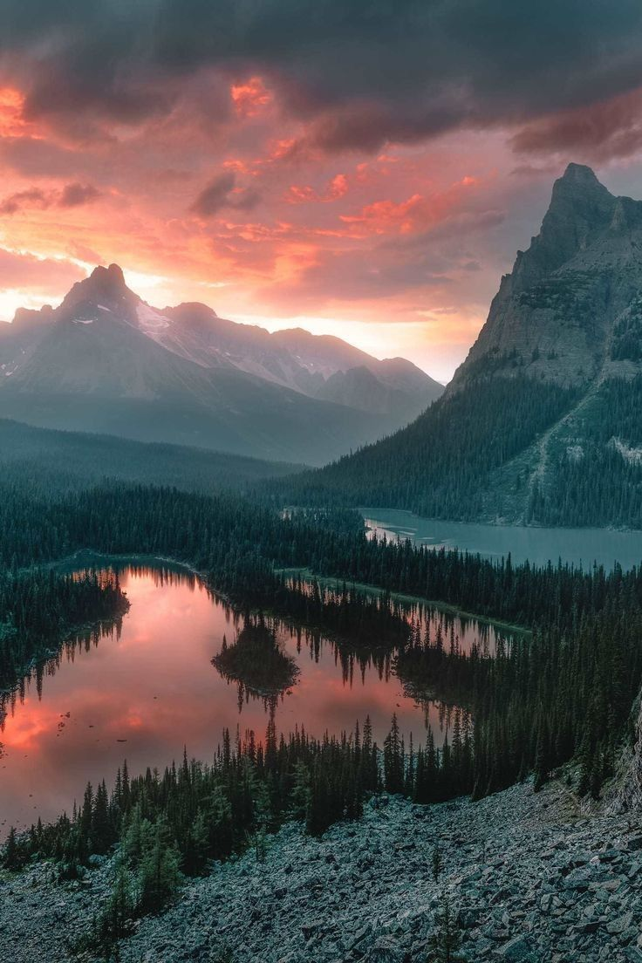

1️⃣ the sunset over lake in jagged peak, alberta of rachel bryant, in the style of light red and emerald, mysterious backdrops, historical imagery, metropolis meets nature, lively nature scenes --ar 2:3

2️⃣ the sunset on top of mountains near a lake in canadian rockies, in the style of light emerald and light crimson, mysterious backdrops --ar 2:3

3️⃣ the sun is setting over the mountains and a lake, in the style of light red and dark emerald, jessica drossin, ansel adams, steve , whistlerian, vibrant stage backdrops, i can't believe how beautiful this is --ar 2:3

4️⃣ sunrise at barren geyser lake, banff national park, in the style of matte painting, red and emerald, zigzags, post-apocalyptic backdrops, hudson river school, the snapshot aesthetic, landscape inspirations --ar 2:3

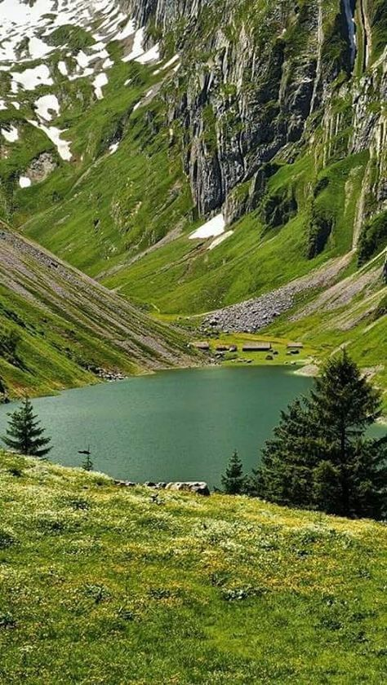

1️⃣ a lake in green grass surrounded by mountains, in the style of swiss style, light green and dark brown --ar 59:105

2️⃣ a lake in summer in a lush green area of hills, in the style of swiss style, light green and dark brown, y2k aesthetic, thechamba, glistening, i can't believe how beautiful this is --ar 59:105

3️⃣ lake kalicho, in the style of pol ledent, romanticized nature --ar 59:105

4️⃣ the lake in the middle of the grassy field, in the style of mountainous vistas, light green and dark brown, kitsch and camp charm, rollei prego 90, y2k aesthetic --ar 59:105

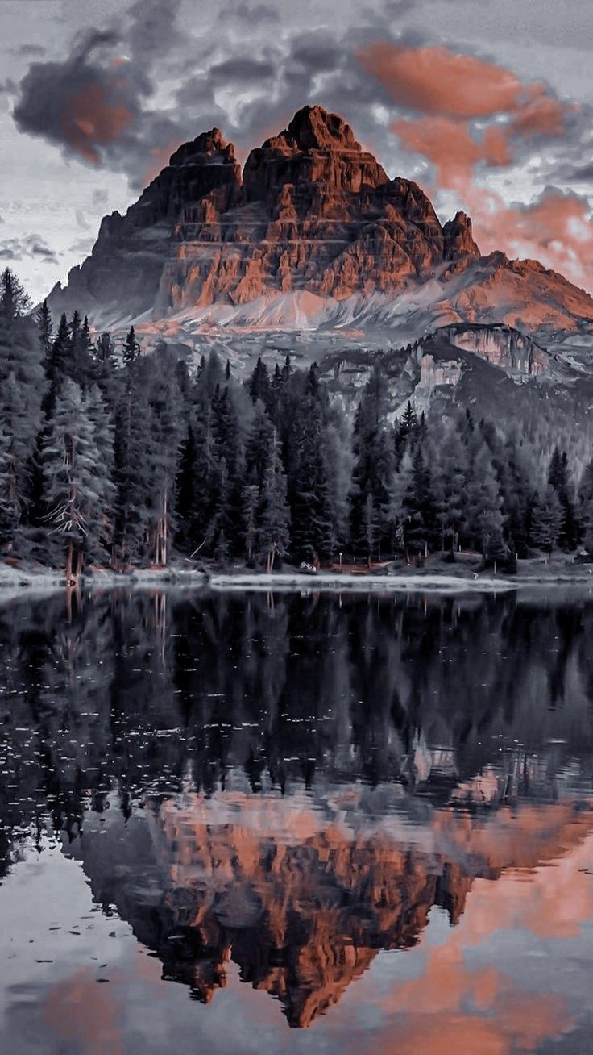

1️⃣ a mountain topped with trees is reflecting in a lake, in the style of light red and dark gray, mysterious backdrops, leica cl, detailed nature depictions, dark amber and white, alexandre calame, light pink and gray --ar 92:163

2️⃣ the mountains and trees are reflected in a body of water, in the style of light red and dark gray, photo-realistic hyperbole, 3840x2160, swiss style, cabincore, landscape inspirations, spectacular backdrops --ar 92:163

3️⃣ the mountains of lenzano reflect mountain at sunset, in the style of dark red and gray, atmospheric woodland imagery, photo-realistic techniques, trace monotone, calm waters, light orange and white, historical imagery --ar 92:163

4️⃣ a mountain sits on top of some water, in the style of dark silver and light red, calming and introspective aesthetic, swiss style, atmospheric woodland imagery, stanley pinker, historical imagery, spectacular backdrops --ar 92:163

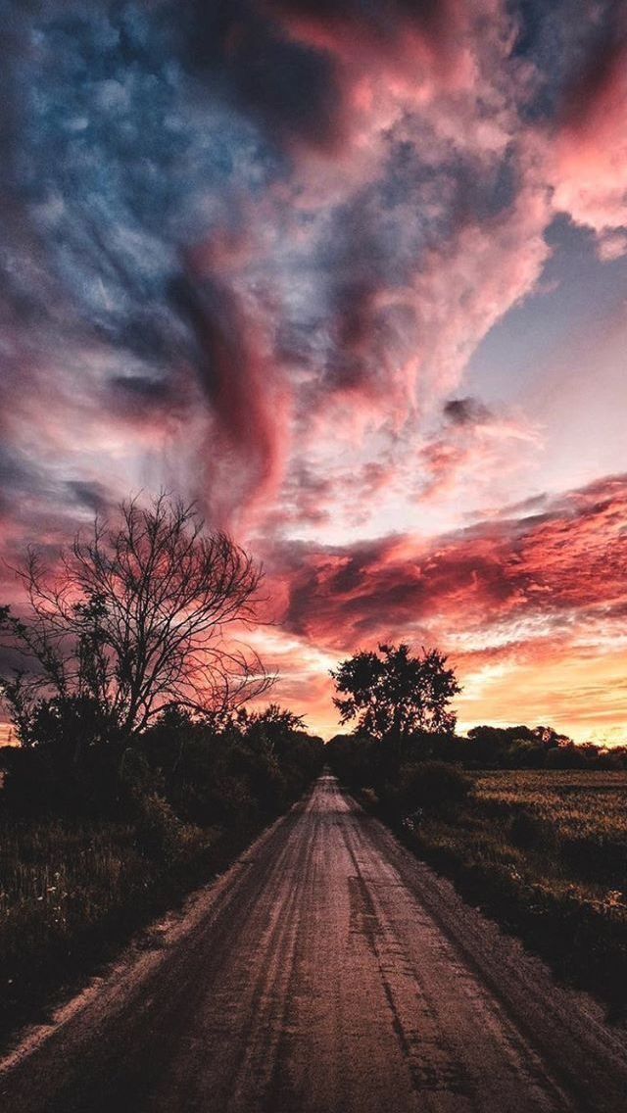

1️⃣ an empty road in the distance with a pink sunset, in the style of #vfxfriday, light crimson and indigo, dreamlike naturaleza, midwest gothic, voigtlander bessa r2m, john constable, rustic scenes --ar 40:71

2️⃣ road at sunset, in the style of the snapshot aesthetic, dark pink and red, dreamlike naturaleza, #vfxfriday, i can't believe how beautiful this is, cloudcore, midwest gothic --ar 40:71

3️⃣ landscapes, road, sunset, road, in the style of the snapshot aesthetic, red and pink, prudence heward, richly colored skies, #vfxfriday, i can't believe how beautiful this is, firecore --ar 40:71

4️⃣ road at sunset in rural chile, in the style of #vfxfriday, dark pink and red, voigtlander brilliant, cloudcore, nature-inspired camouflage, i can't believe how beautiful this is, midwest gothic --ar 40:71

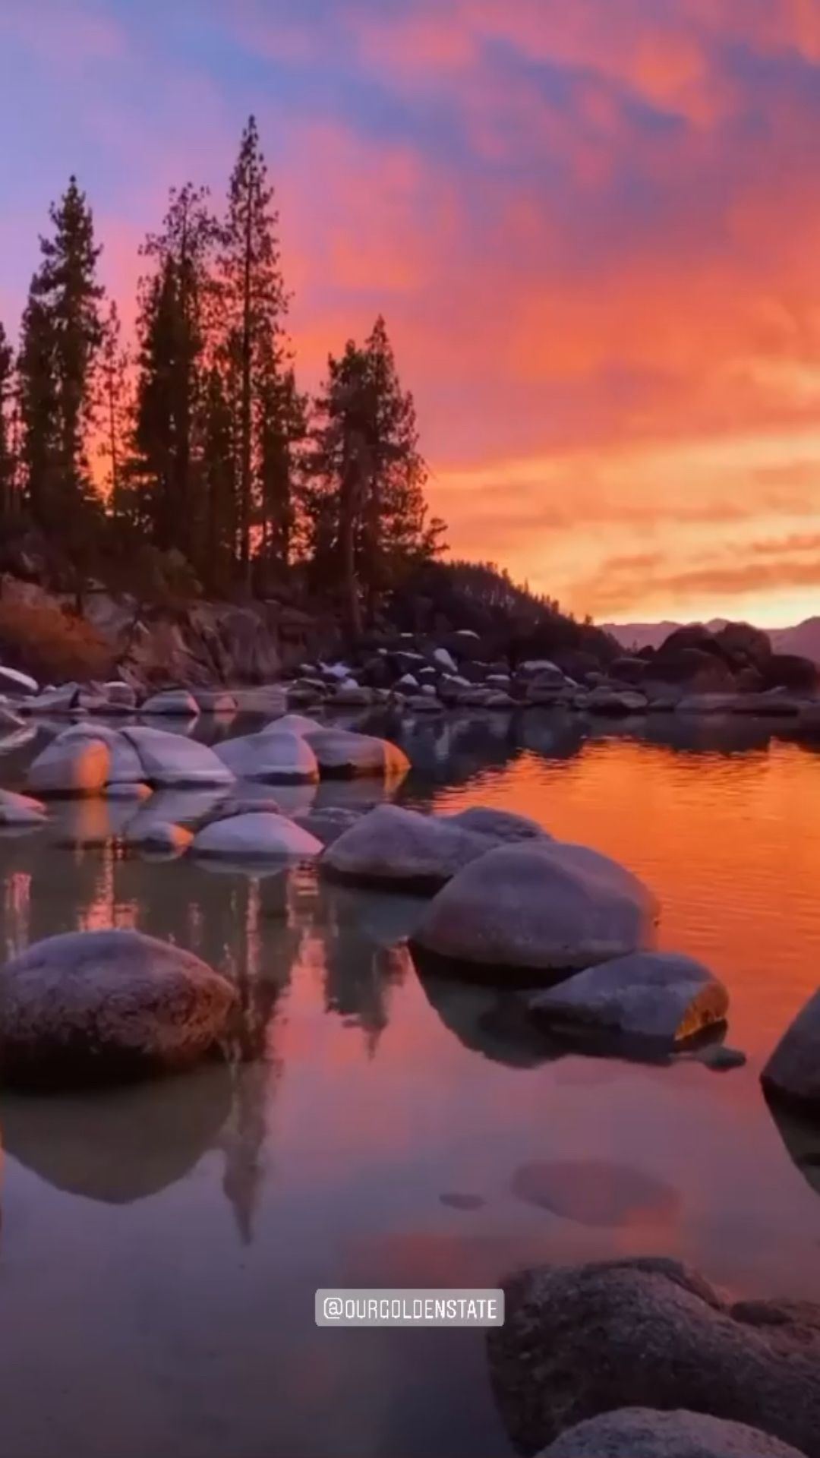

1️⃣ the sun is setting on a beautiful water filled with rocks, in the style of psychedelic soundscapes, ed freeman, michael shainblum --ar 9:16

2️⃣ sunset over a beautiful lake with rocks and trees, in the style of 32k uhd, psychedelic-inspired, california plein air, i can't believe how beautiful this is, video montages, national geographic photo --ar 9:16

3️⃣ a colorful sunset is seen over huge rocks in the sea, in the style of video glitches, ansel adams, wilderness, i can't believe how beautiful this is, evgeny lushpin, nature scenes, reflections --ar 9:16

4️⃣ a sunset image from a beach near a tree, in the style of psychedelic soundscapes, epic landscapes --ar 9:16

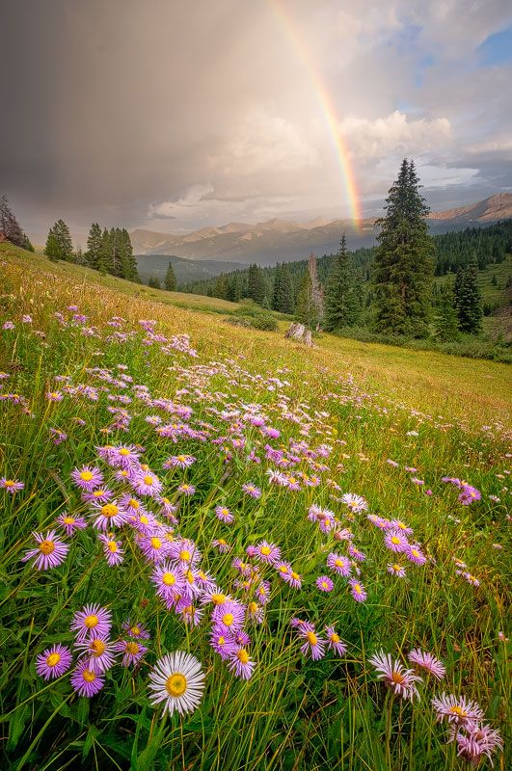

1️⃣ a rainbow and purple daisies lie on a green area under an approaching storm, in the style of max rive, martin grelle, flickr, richard misrach, light pink and yellow, sublime wilderness, cabincore --ar 33:50

2️⃣ flowers in meadow under rainbow, in the style of topographic photography, whistlerian, i can't believe how beautiful this is, landscape inspirations, cabincore, naturalist, contest winner --ar 33:50

3️⃣ rainbow and daisies photo, in the style of wilderness, martin rak, whistlerian, david nordahl, lush scenery, felicia simion, violet and gold --ar 33:50

4️⃣ rainbow in a meadow filled with flowers and sunflowers, in the style of whistlerian, enchanting realms --ar 33:50

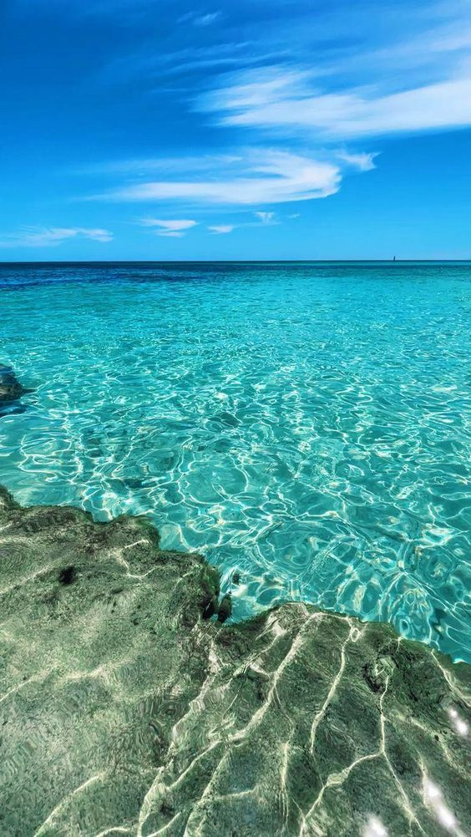

1️⃣ a clear sea with white rocks and clear blue water, in the style of light blue and teal, vacation dadcore, sharp & vivid colors, reefwave, webcam photography, calm waters, light brown and turquoise --ar 14:25

2️⃣ the bottom of the ocean in crystal clear water, in the style of calm waters, turquoise and silver, vacation dadcore, flickr, afro-caribbean influence, vibrant, lively, ferrania p30 --ar 14:25

3️⃣ a beautiful turquoise sea water with rocks in it, in the style of eiichiro oda, mesmerizing optical illusions, art of tonga, creative commons attribution, i can't believe how beautiful this is, clear colors, calm waters --ar 14:25

4️⃣ a colorful ocean scene with many rocks and clear blue water, in the style of turquoise and silver, slim aarons, flickr, art of tonga, glassy translucence, transavanguardia --ar 14:25

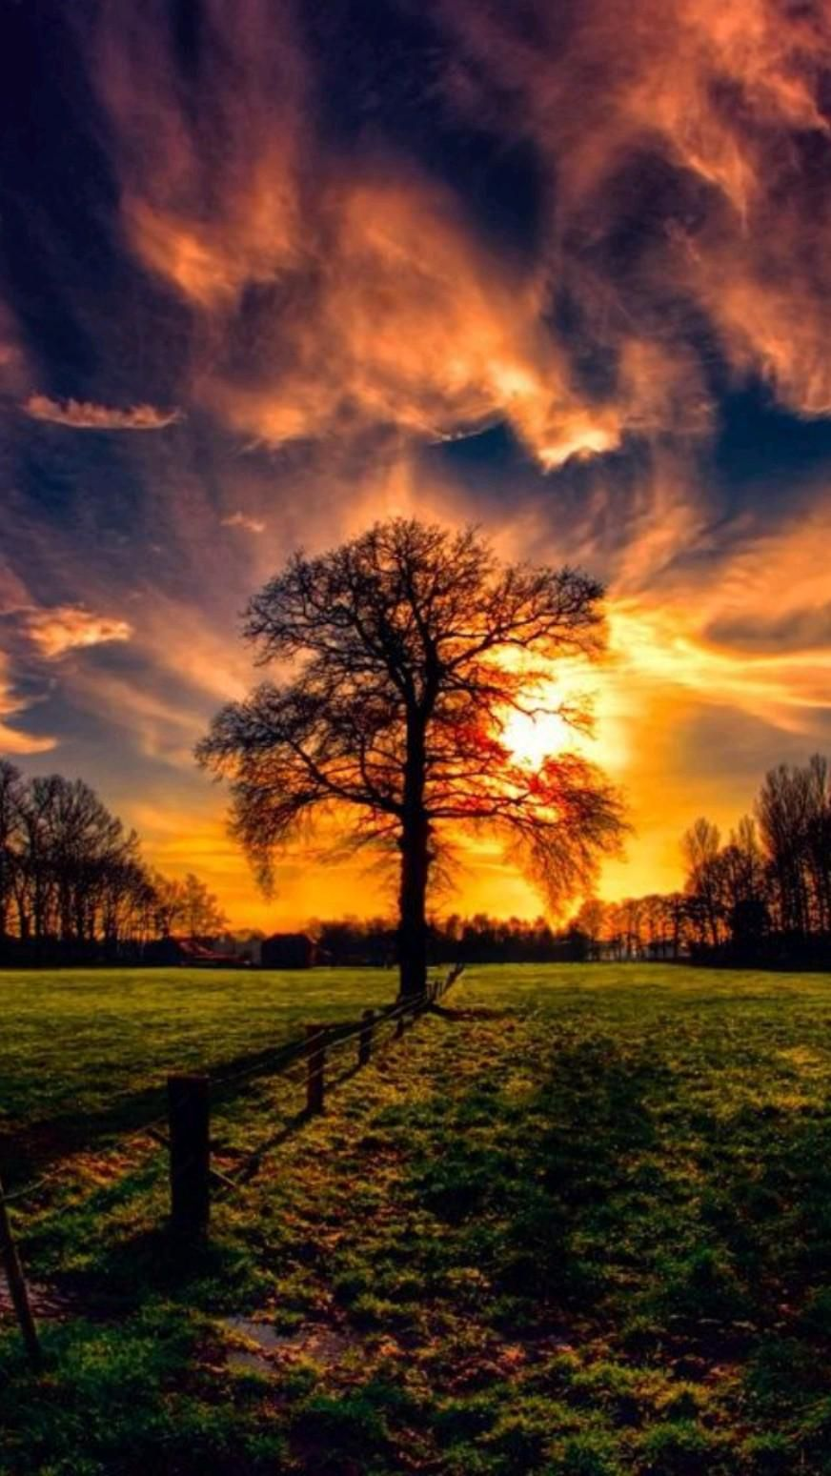

1️⃣ a sunset is depicted in a large field with a tree, in the style of bright and vivid colors, spectacular backdrops --ar 109:193

2️⃣ a tree in a field by the setting sun, in the style of vivid dreamscapes, impressive skies, pastoral charm --ar 109:193

3️⃣ a tree is isolated in a sunset and a field, in the style of photo-realistic landscapes, vivid dreamscapes, english countryside scenes --ar 109:193

4️⃣ 10 desktop wallpapers a tree in the lawn, in the style of richly colored skies, romantic emotivity, giorgione, emotional landscapes --ar 109:193

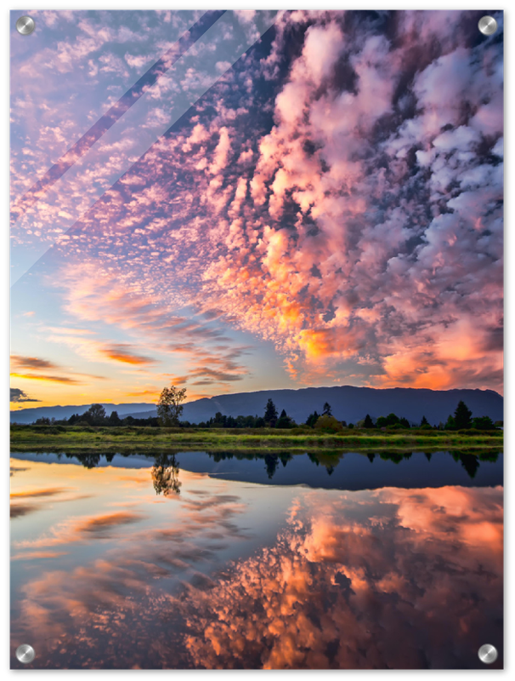

1️⃣ a reflection that shows water and sky, in the style of richly colored skies, mitch griffiths, don maitz, elihu vedder, nikon af600, pastoral charm, light black and pink --ar 3:4

2️⃣ sunset scene with colorful clouds, in the style of reflections and mirroring, nikon af-s nikkor 70-200mm f/2.8e fl ed vr, california impressionism, vancouver school, impressionist sensibilities, isolated landscapes, pointillist optical illusions --ar 3:4

3️⃣ pink, purple, orange and yellow clouds, in the style of reflections and mirroring, steinheil quinon 55mm f/1.9, the vancouver school, serene pastoral scenes, pointillist nature scenes, detailed perfection, impressionist sensibilities --ar 3:4

4️⃣ a lake reflected in the picture, in the style of richly colored skies, rodel gonzalez, detailed skies, stanley pinker, vancouver school, emek golan, joyful celebration of nature --ar 3:4

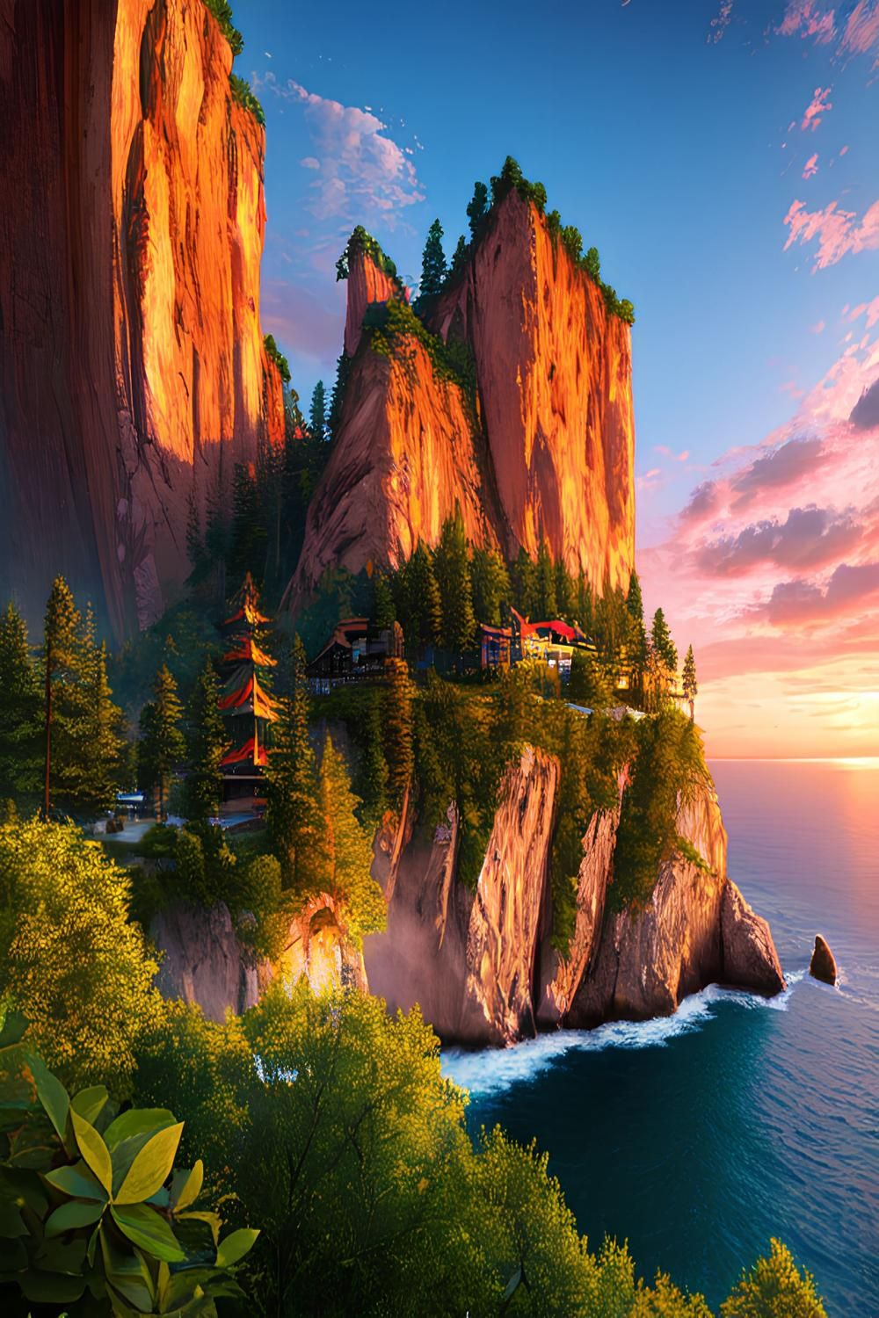

1️⃣ a view of the ocean and rocky cliffs with houses, in the style of vibrant fantasy landscapes, vray, asian-inspired, dmitry spiros, 8k resolution, mountainous vistas, xbox 360 graphics --ar 125:187

2️⃣ a scenic view of mountains and ocean, in the style of orient-inspired, 32k uhd, dima dmitriev, detailed world-building, cliff chiang, vibrant colors in nature, xbox 360 graphics --ar 125:187

3️⃣ seashore scenery wallpaper wallpapers, wallpaper, photohd, oc, landscapes, waterfall, summer, scenery, water, scenery, in the style of playstation 5 screenshot, asian-inspired, detailed world-building, mountainous vistas, bryce 3d, photo taken with nikon d750, disney animation --ar 125:187

4️⃣ hd wallpapers: beautiful desert landscapes wallpapers for desktop, in the style of playstation 5 screenshot, confucian ideology, coastal scenery, isometric, photo taken with nikon d750, detailed world-building, norwegian nature --ar 125:187

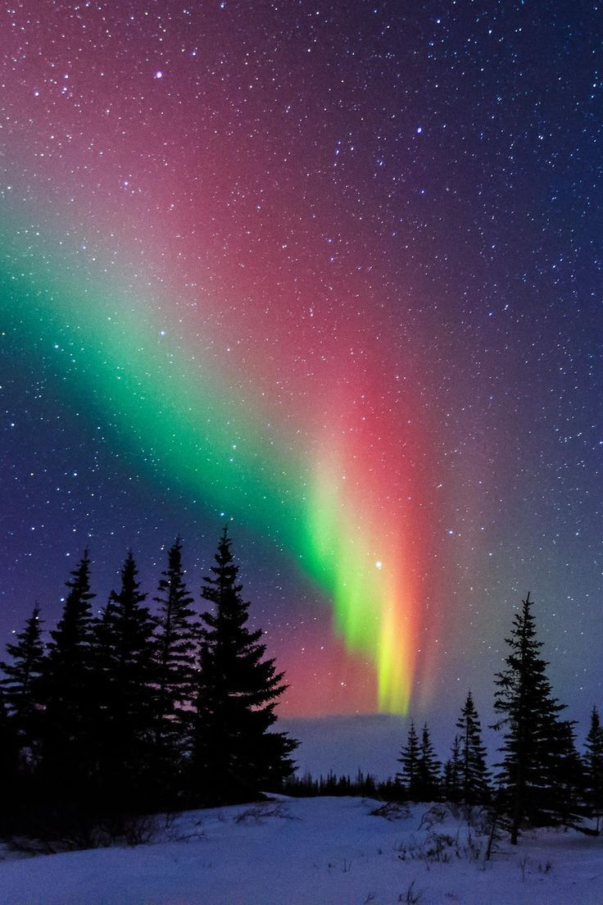

1️⃣ the northern lights are shown in the sky, in the style of light red and emerald, bess hamiti, light sky-blue and pink, ingrid baars, associated press photo, forestpunk, a. j. casson --ar 2:3

2️⃣ an aurora pole glows over trees, snow and snowy peaks in the night sky, in the style of light crimson and emerald, light teal and dark pink, 1970–present, rtx on, xmaspunk, whistlerian, dark sky-blue and light amber --ar 2:3

3️⃣ a green and multicolored aurora bore over a snowy country, in the style of light crimson and dark aquamarine, xmaspunk, light red and indigo, light black and pink, matti suuronen, enchanting lighting, large-scale murals --ar 2:3

4️⃣ aurora borealis over snowy terrain, in the style of dark pink and teal, light red and emerald --ar 2:3

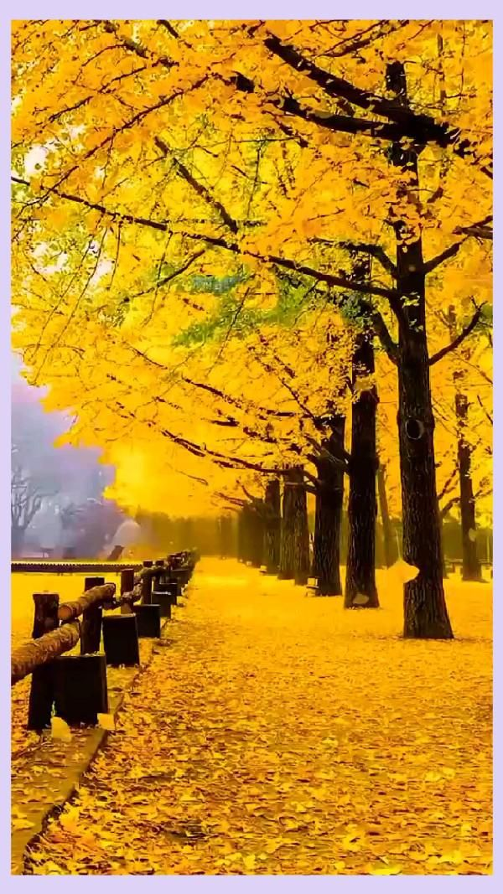

1️⃣ a yellow scene with benches and colorful trees, in the style of mysterious backdrops, qian xuan, 32k uhd, yellow and amber, monochromatic masterpieces, yellow and purple, captivating scenes --ar 75:133

2️⃣ an autumn walking path and yellow trees, in the style of the stars art group (xing xing), mysterious backdrops, 32k uhd, yellow, vibrant, exaggerated scenes, nostalgic scenes, poetic pastoral scenes --ar 75:133

3️⃣ yellow twigs and trees line a path and tree., in the style of spectacular backdrops, li shuxing, time-lapse photography, sung kim, soft, romantic scenes, vivid color, yellow and amber --ar 75:133

4️⃣ the autumn tree line with yellow leaves, a bench and a blue sky, in the style of the stars art group (xing xing), realistic color schemes, 32k uhd, captivating scenes, mysterious and dreamlike scenes, yellow, realistic scenes --ar 75:133

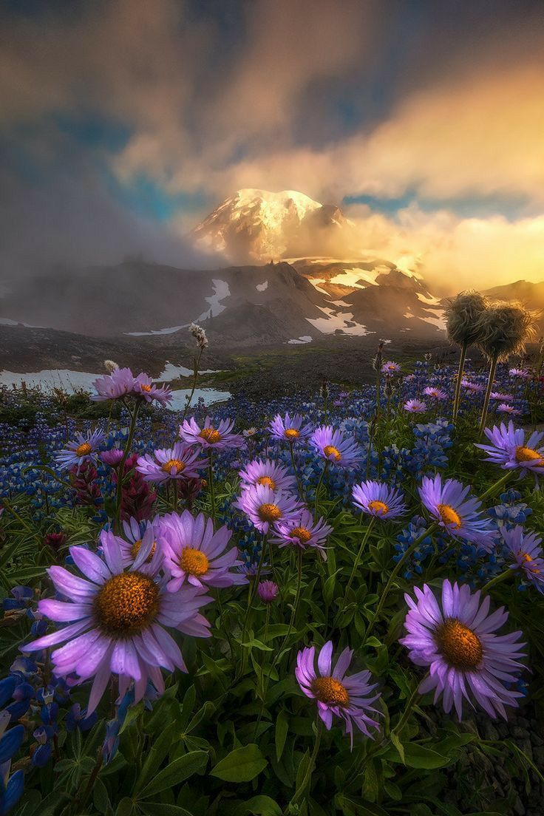

1️⃣ the flowers are in the foreground near the mountain at sunset,, in the style of filip hodas, ildiko neer, michael shainblum, naturalist aesthetic, magewave, weathercore, nature scenes --ar 2:3

2️⃣ a sunrise scene in the fog with red and purple daisies, in the style of gravity-defying landscapes, contest winner, hyperrealistic wildlife portraits, whistlerian, i can't believe how beautiful this is, dramatic skies, vibrant stage backdrops --ar 2:3

3️⃣ some colorful wildflowers and a mountain in the background, in the style of josh adamski, noah bradley, max rive, dramatic atmospheric perspective, national geographic photo, violet and bronze, associated press photo --ar 2:3

4️⃣ montane photo of purple flowers on the moors by scott adams, in the style of native american, first nations, and alaska native art, contest winner, i can't believe how beautiful this is, epic fantasy scenes, richly layered, light amber and azure, highly detailed environments --ar 2:3

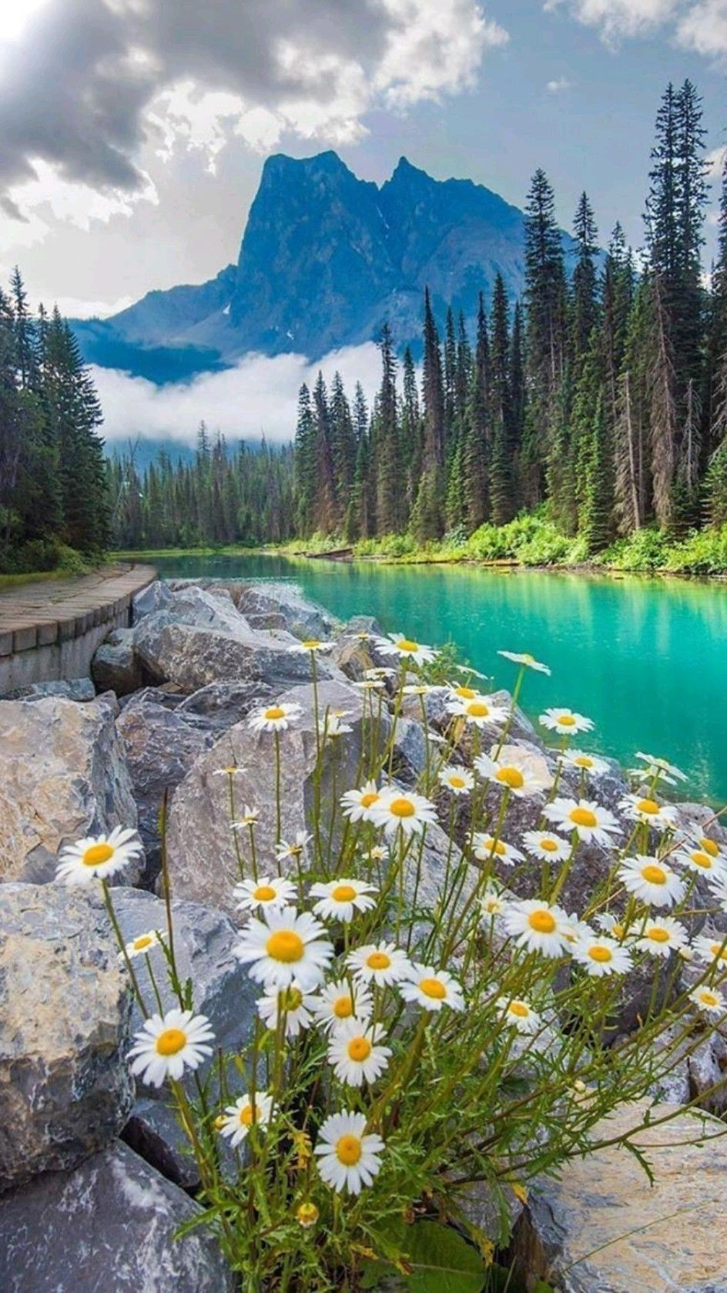

1️⃣ landscape, waterfall, waterfall landscape, white daisies, mountains, waterfall landscape, lake, waterfall sunrise, landscape, sky, scenic, blue, scenery, nature, color, in the style of turquoise and emerald, whistlerian, grandiose environments, yellow and emerald, natural beauty --ar 118:209

2️⃣ a large lake that resembles a turquoise color and flowers in the foreground, in the style of rustic charm, whistlerian, environmental awareness, dark white and yellow, david nordahl, travel, clear colors --ar 118:209

3️⃣ blooming daisies in water by the lake, in the style of whistlerian, spectacular backdrops --ar 118:209

4️⃣ the rocky shore is flanked by daisies and trees, in the style of light emerald and turquoise, whistlerian, environmental awareness, colorful gardens, jessica drossin --ar 118:209

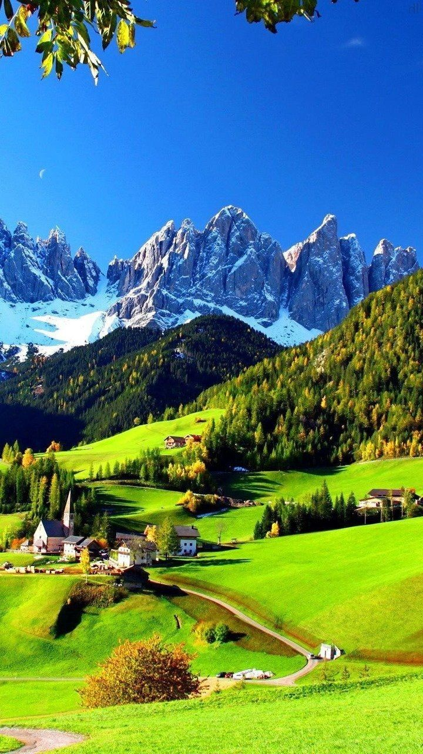

1️⃣ wallpapers by the dolomites, in the style of french countryside, emerald and blue, use of bright colors, detailed world-building, emphasis on nature, yellow and green, romanticized views --ar 9:16

2️⃣ a landscaped forest filled with trees and dolmetscher peaks, in the style of eye-catching, richly colored, villagecore, flickr, italian landscapes, windows xp, romantic landscape vistas --ar 9:16

3️⃣ snow capped mountains snw, in the style of charming, idyllic rural scenes, emerald and blue, international gothic, 8k resolution, brightly colored, italian landscapes, creative commons attribution --ar 9:16

4️⃣ a photo showing a quaint little village in the countryside, in the style of mesmerizing colorscapes, mountainous vistas, emerald and blue, rimel neffati, pristine naturalism, clear and crisp, utilizes --ar 9:16

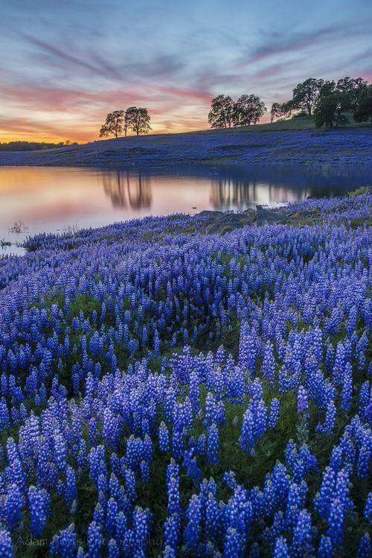

1️⃣ a scene of bluebonnets at sunrise by johnny mcfly and jay schamp, in the style of calm waters, howardena pindell, david burdeny, violet and bronze, ephraim moses lilien, flickr, uhd image --ar 2:3

2️⃣ bluebonnets in texas by greg mccormack for photo album, in the style of calm waters, spectacular backdrops, mesmerizing colorscapes, landscape photography, luminescent color scheme --ar 2:3

3️⃣ photograph bluebonnets in bloom by danny mclean, in the style of romantic riverscapes, spectacular backdrops, american tonalist, mesmerizing colorscapes, tetsuya ishida, serene pastoral scenes, violet and orange --ar 2:3

4️⃣ poster photograph the bluebonnets by gary kahl, in the style of spectacular backdrops, romantic riverscapes, purple and azure, time-lapse photography, american tonalist, nature scenes, flickr --ar 2:3

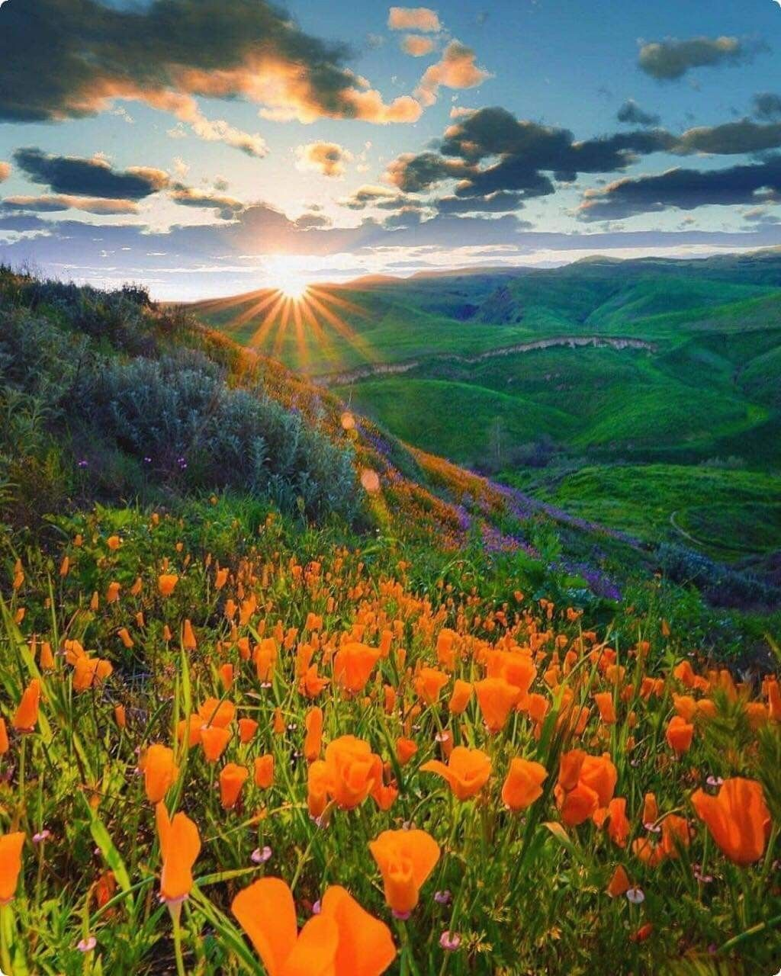

1️⃣ sunset over the poppy field with lots of bright orange flowers, in the style of mountainous vistas, brandon woelfel, joel sternfeld, light emerald and yellow, landscape mastery, steve hanks, photo-realistic landscapes --ar 4:5

2️⃣ sunset over flowers on the mountain top, in the style of orange and green, photo-realistic landscapes, california plein air, 32k uhd, romantic landscapes, elaborate landscapes, large scale murals --ar 4:5

3️⃣ the sunset in the woods of california, in the style of flower power, emek golan, photo-realistic landscapes, mountainous vistas, 32k uhd, gari melchers, orange and green --ar 4:5

4️⃣ a beautiful sunset timer with poppies and grass on screen, in the style of mountainous vistas, the san francisco renaissance., sunrays shine upon it, i can't believe how beautiful this is, topographic photography, orange and emerald, harmony with nature --ar 4:5

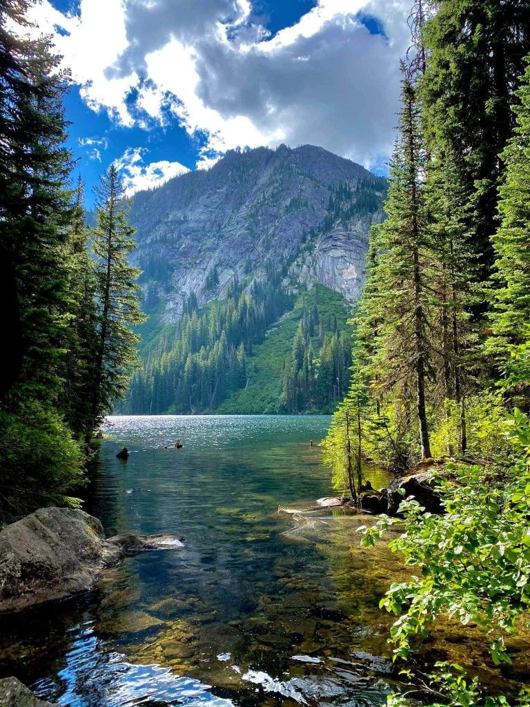

1️⃣ image of a surrounded lake in the woods, in the style of mountainous vistas, nikon d850, i can't believe how beautiful this is --ar 3:4

2️⃣ the lake is surrounded by trees in an environment of trees, in the style of 32k uhd, whistlerian, anatoly metlan, yashica t4, light emerald and dark brown, martin grelle, nature --ar 3:4

3️⃣ photograph cascade lake photo by devria p pyle, in the style of 32k uhd, secluded settings, martin grelle, green and blue, sublime wilderness, nonrepresentational --ar 3:4

4️⃣ photograph lafayette caldera lake by mike willer, in the style of light navy and green, y2k aesthetic, whistlerian, cabincore, light maroon and dark emerald, realistic naturalism, photo taken with provia --ar 3:4

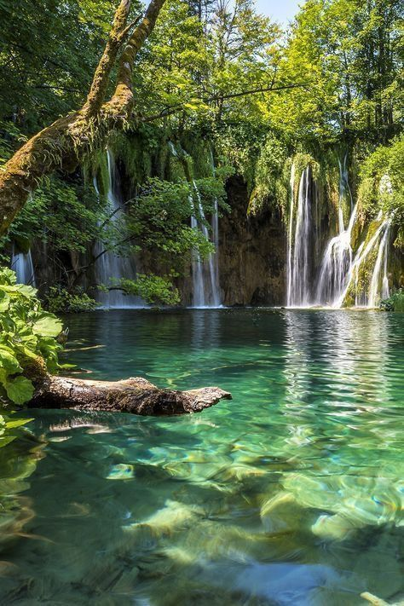

1️⃣ waterfalls in trees with clear water in plitvice lakes, in the style of nature-inspired pieces, dark teal and light green, indigenous culture, nature studies, naturalistic materials, kimoicore, terragen --ar 59:88

2️⃣ the plitvice waterfalls in croatia, in the style of dark teal and light green, nature-inspired pieces, naturalistic materials, gerald harvey jones --ar 59:88

3️⃣ plitvice waterfalls, croatia travel guide, in the style of dark white and green, naturalistic rendering, nature-inspired camouflage, eco-friendly craftsmanship, naturecore, dark blue and turquoise, mysterious jungle --ar 59:88

4️⃣ riplat national park in croatia, italy, in the style of dark aquamarine and white, mysterious jungle, duckcore, creative commons attribution, magali villeneuve, fluid, joyful celebration of nature --ar 59:88

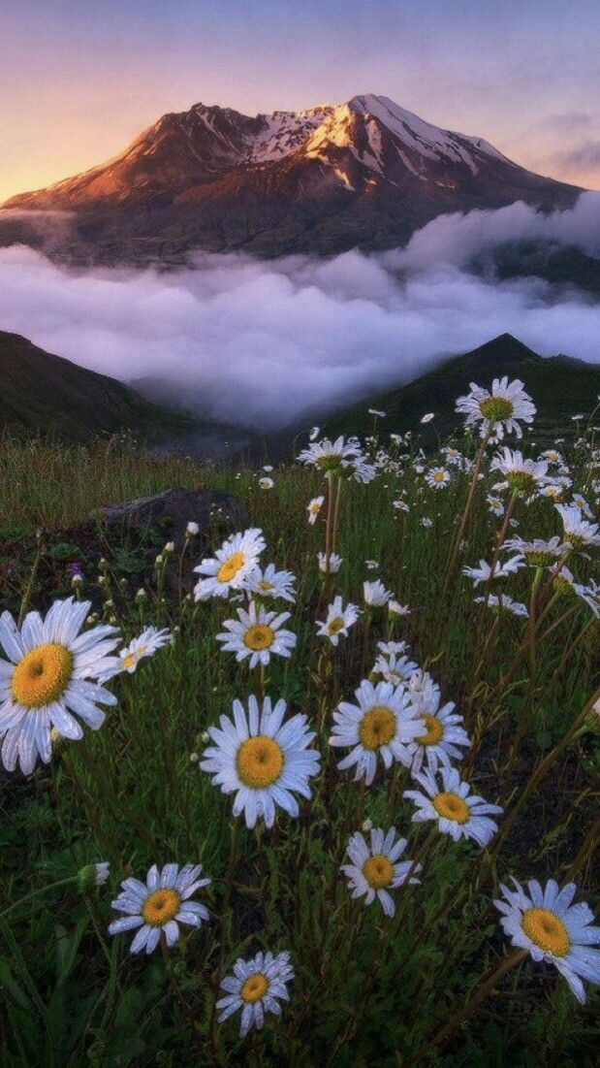

1️⃣ a group of daisies in the middle of the mountains, in the style of ethereal dreamscapes, flowerpunk, i can't believe how beautiful this is --ar 77:137

2️⃣ montana at sunrise with daisies on the ground, in the style of alejandro jodorowsky, i can't believe how beautiful this is, misty atmosphere, mountainous vistas, ivan fedorovich choultse, nature studies, impressionist sensibilities --ar 77:137

3️⃣ images inspired by sunrises the photo gallery from instagram, in the style of delicate flowers, mountainous vistas, zeiss batis 18mm f/2.8, cloudpunk, quito school, naturalist, national geographic photo --ar 77:137

4️⃣ ice cream cone mountains hd wallpaper images, in the style of flower and nature motifs, hasselblad 1600f, fay godwin, atmospheric clouds, andrzej sykut, marguerite blasingame, anime aesthetic --ar 77:137

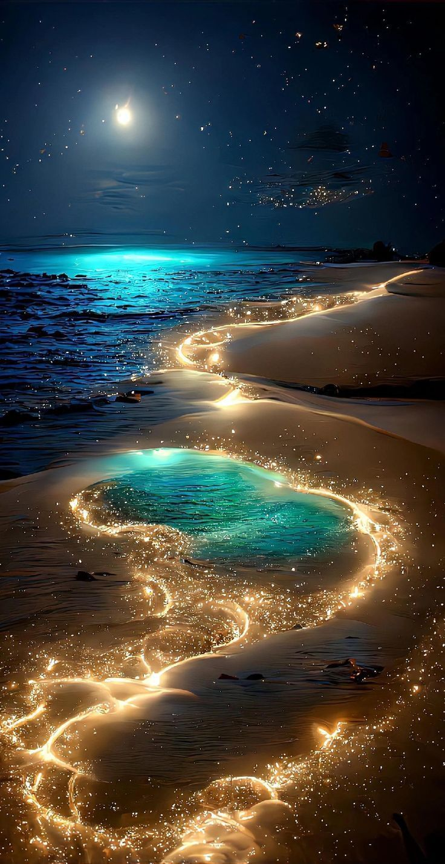

1️⃣ silver and gold lights and blue and starry ocean with the moon in the sky, in the style of lovecraftian, saturated pigment pools, enchanting lighting, swirling vortexes, whimsical wonders, captivating, emotional imagery, glowing lights --ar 46:89

2️⃣ glitter on the sand, in the style of bioluminescence, dreamy symbolism, digital art wonders, glowing lights, realistic seascapes --ar 46:89

3️⃣ a light shining in the ocean with colorful stones, in the style of dark turquoise and light gold, fairy tale illustrations, swirling vortexes, i can't believe how beautiful this is, glowing lights, coastal scenes, glittery and shiny --ar 46:89

4️⃣ sparks on the beach at night, in the style of turquoise and gold, delicate fantasy worlds, lovecraftian, hyper-realistic water, i can't believe how beautiful this is, mystical terrains, glittery and shiny --ar 46:89

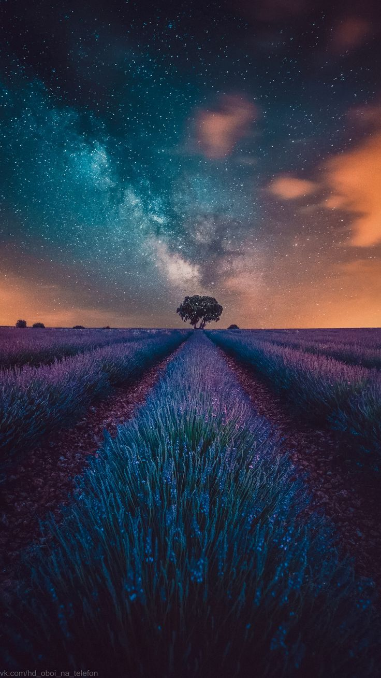

1️⃣ lavender fields with night skies and the milky way in the background, in the style of dark turquoise and light orange, constructed photography, juxtaposed imagery, light black and purple, documentary travel photography, precise perspective, mysterious backdrops --ar 92:163

2️⃣ lavender fields under starry skies landscape with a blue lavender field, in the style of filip hodas, mysterious backdrops, dark white and orange, captivating visual storytelling, niko henrichon, dreamlike perspectives, atmospheric urbanscapes --ar 92:163

3️⃣ lavender field in france under the milky way, in the style of dark turquoise and dark orange, jessica drossin, narrative-driven visual storytelling, dark white and violet, saturno butto, atmospheric, low-angle --ar 92:163

4️⃣ the lavender fields are lit up by the milky way, in the style of light orange and dark cyan, surreal storytelling, schlieren photography, night photography, spectacular backdrops, dark sky-blue and violet, low-angle --ar 92:163

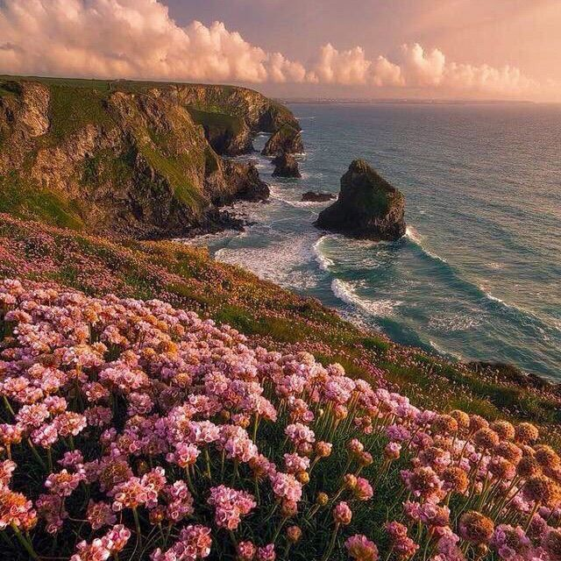

1️⃣ beautiful flowers at sunset by a cliff along the coast of cornwall, in the style of kitsch aesthetic, national geographic photo, grandeur of scale, #vfxfriday, british topographical, weathercore, iberê camargo

2️⃣ pink flowers on a cliff near a beautiful cliff, in the style of traditional british landscapes, ocean academia, #vfxfriday, golden light, mesmerizing colorscapes, snapshot aesthetic, i can't believe how beautiful this is

3️⃣ pink flowers spread out along the coast into the ocean, in the style of british topographical, golden light, mallgoth, #vfxfriday, dreamlike naturaleza, charles spencelayh, i can't believe how beautiful this is

4️⃣ pink flowers growing into the grass on the coast, in the style of elaborate landscapes, british topographical

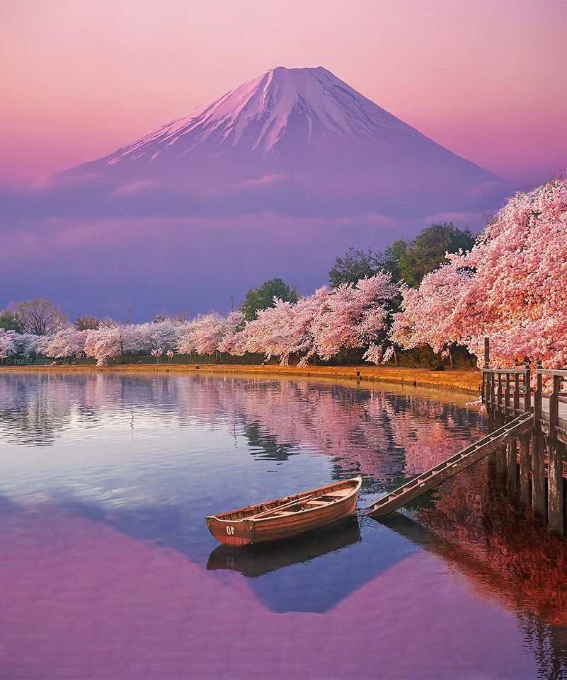

1️⃣ two boats and cherry trees with fuji in the background, in the style of mesmerizing colorscapes, lovely, i can't believe how beautiful this is, national geographic photo, matte painting --ar 5:6

2️⃣ mountain mueki in cherry blossoms with a small boat, in the style of mesmerizing colorscapes, dreamy landscapes --ar 5:6

3️⃣ a boat on the water in front of fuji, in the style of mesmerizing colorscapes, david nordahl, cherry blossoms, flickr, vibrant colors in nature, light magenta and brown, i can't believe how beautiful this is --ar 5:6

4️⃣ a picture with a boat and a pink flower overlooking a mountain, in the style of japanese-style landscapes, mesmerizing colorscapes --ar 5:6

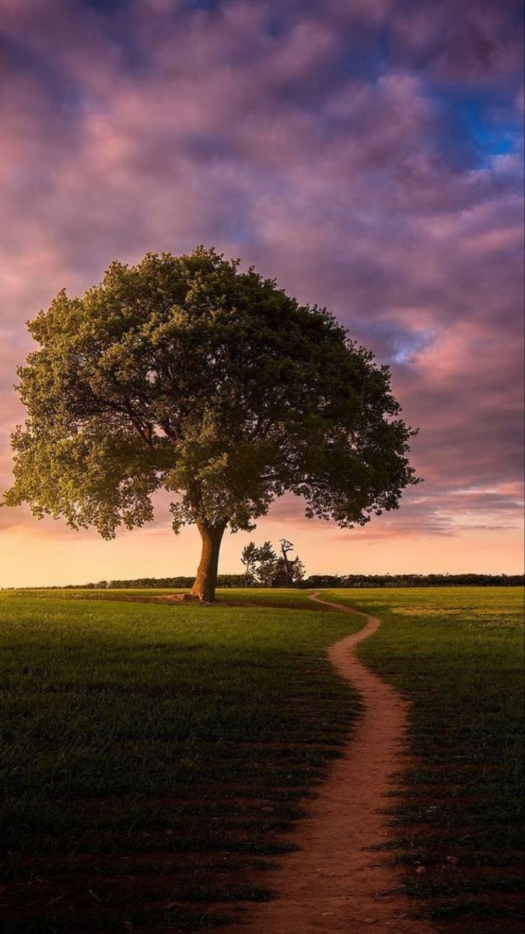

1️⃣ a tree on a path at sunset, in the style of mesmerizing optical illusions, serene pastoral scenes --ar 14:25

2️⃣ a single tree stands between the light filled sky, in the style of tom chambers, nikon d850, michael whelan, photo taken with provia, depiction of everyday life, i can't believe how beautiful this is, charles willson peale --ar 14:25

3️⃣ lone tree in the field, in the style of mesmerizing optical illusions, spectacular backdrops, romantic emotivity, uhd image --ar 14:25

4️⃣ pathway to beauty full screen wallpaper 1920x1080, in the style of bess hamiti, arthur tress, english countryside scenes, uhd image, caras ionut, dusseldorf school of photography, violet and green --ar 14:25

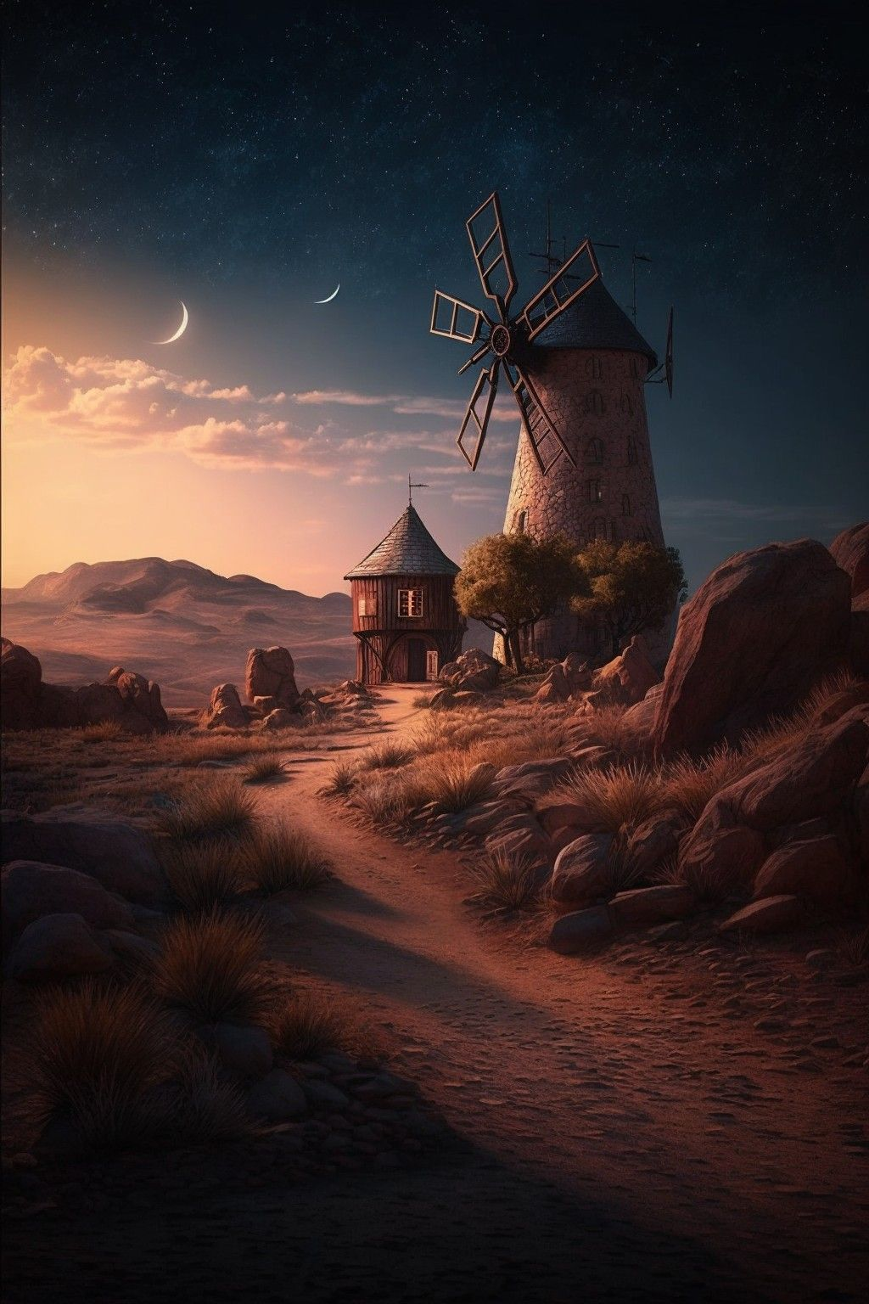

1️⃣ a beautiful painting of a windmill at night with the moon, in the style of matte painting, photo-realistic landscapes, light crimson and light brown --ar 2:3

2️⃣ ancient stone windmill, desert wallpaper, stone windmill, isolated rock, wallpaper, hd, isolated rock, mountain, landscape, desert, desert wallpaper, in the style of romantic moonlit seascapes, hyperrealistic paintings, dark crimson and magenta, i can't believe how beautiful this is, cute and dreamy, realistic landscapes with soft, tonal colors, sepia tone --ar 2:3

3️⃣ the windmill on a mountain side at sunset, in the style of mystical creatures and landscapes, photo-realistic landscapes, the stars art group (xing xing), dark crimson and beige --ar 2:3

4️⃣ another image of a lonely windmill in an empty desert, in the style of darkly romantic illustrations, photo-realistic landscapes, the stars art group (xing xing), epic fantasy scenes, english countryside scenes, tonalist paintings, matte photo --ar 2:3

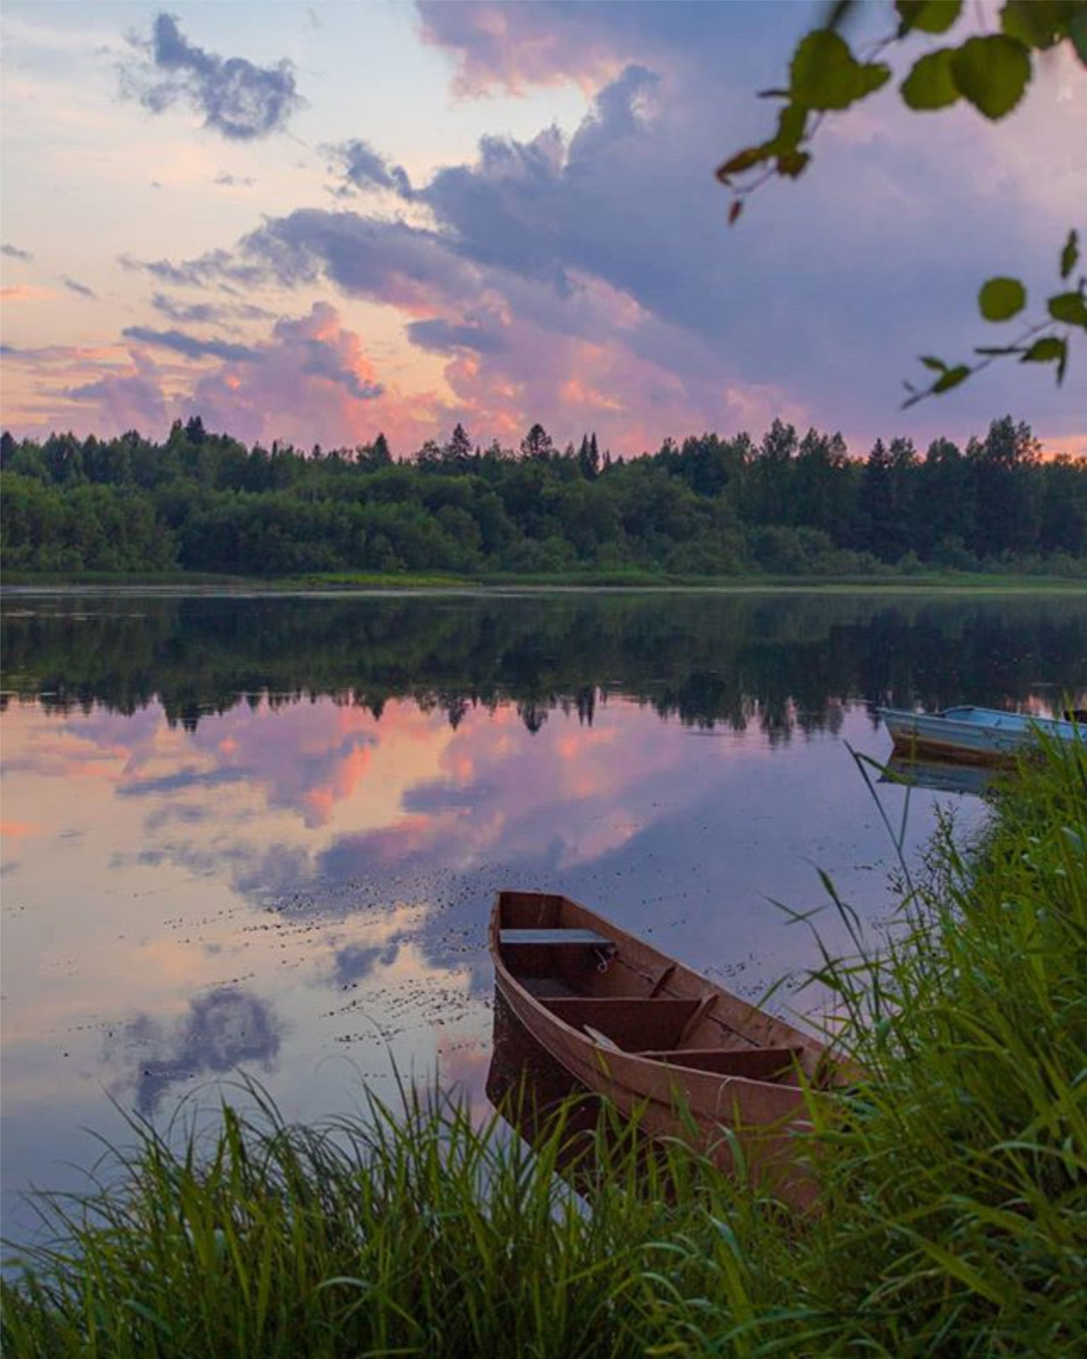

1️⃣ two wooden canoes are next to the shore of a lake at sunset, in the style of #vfxfriday, naturecore, i can't believe how beautiful this is, atmospheric clouds, celebration of rural life, cabincore, visually poetic --ar 275:343

2️⃣ sunset on a lake with two canoes on the side, in the style of #vfxfriday, naturecore, delicate landscapes, colorful woodcarvings, atmospheric clouds, i can't believe how beautiful this is, barbizon school --ar 275:343

3️⃣ two canoes on the edge of a lake after sunset, in the style of #vfxfriday, eugene tertychnyi, naturecore, pretty, rusticcore, light magenta and brown, i can't believe how beautiful this is --ar 275:343

4️⃣ two wooden canoes sit docked on the shore of a lake at sunset, in the style of eugene tertychnyi, light magenta and dark brown, atmospheric woodland imagery, #vfxfriday, svetlin velinov, poetic pastoral scenes, arkhyp kuindzhi --ar 275:343

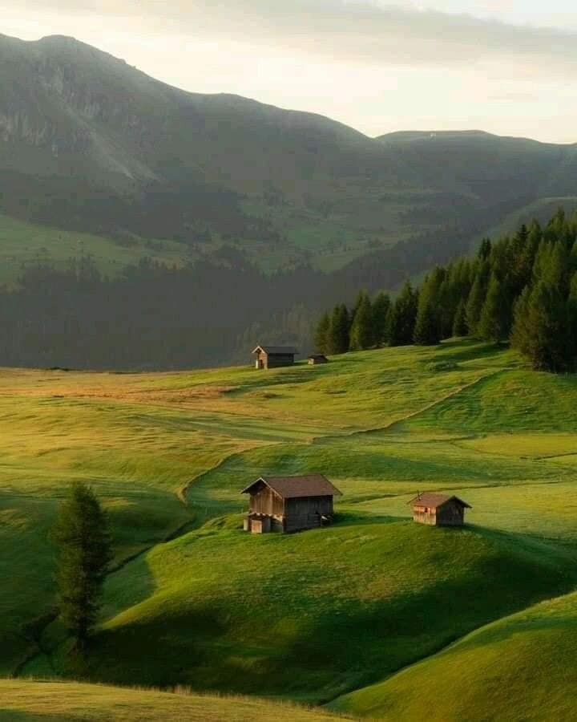

1️⃣ a small field with farm houses on the top, in the style of serene and peaceful ambiance, landscape inspirations, swiss style, dark gold and emerald, cabincore, whistlerian, naturalism --ar 45:56

2️⃣ a lush grass field, in the style of cabincore, italian landscapes, i can't believe how beautiful this is, swiss style, dark green and light brown, natural scenery, mountainous vistas --ar 45:56

3️⃣ a farm at sunrise, in the style of swiss style, dark emerald and light brown, cabincore, whistlerian, landscape inspirations, ferrania p30 --ar 45:56

4️⃣ a green hillside with a lake behind it, in the style of swiss style, romanticized country life, #vfxfriday, national geographic photo, cabincore, sparse backgrounds, light orange and dark green --ar 45:56

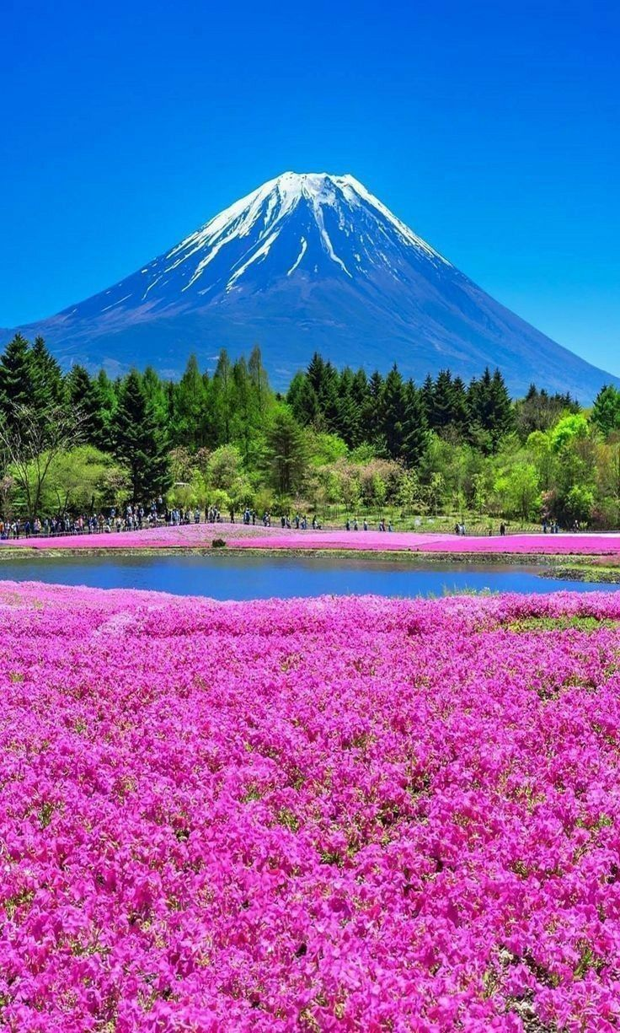

1️⃣ mount fuji in the field of pink flowers, in the style of purple and emerald, romantic riverscapes, sharp & vivid colors, anime aesthetic, purple and brown, nature-inspired, bold, vibrant colors --ar 92:153

2️⃣ mt fuji in a field bloomed with purple flowers, in the style of romantic riverscapes, mesmerizing colorscapes --ar 92:153

3️⃣ a small lake and pink flowers in front of mount fuji, in the style of purple and emerald, bold, colorful, large-scale, villagecore, environmental awareness, spectacular backdrops, multilayered --ar 92:153

4️⃣ pink flowers on the field of kimono fuji in japan, in the style of photo-realistic landscapes, purple, psychedelic landscapes, i can't believe how beautiful this is, mesmerizing colorscapes --ar 92:153

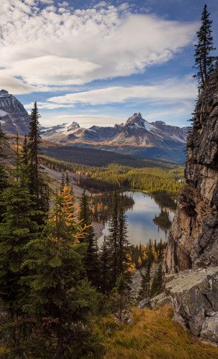

1️⃣ a mountain range near rocky lake in autumn, in the style of environmental portraiture, graham ingels, iconic, tom grummett, photo taken with nikon d750, heather theurer, flickr --ar 19:31

2️⃣ a view of a lake surrounded by pine trees and mountains, in the style of dark amber and silver, large format lens, patrick brown, zigzags, anglocore, spectacular show of ages, donald pass --ar 19:31

3️⃣ geat point falls, banff national park, in the style of sony fe 12-24mm f/2.8 gm, grandiose cityscape views, light gray and dark amber, monumental murals, national geographic photo, wilderness, zigzags --ar 19:31

4️⃣ this is in the background of a rocky landscape with mountains and lakes, in the style of nikon d850, vancouver school, dark silver and amber, associated press photo, forestpunk, zigzags, busy landscapes --ar 19:31

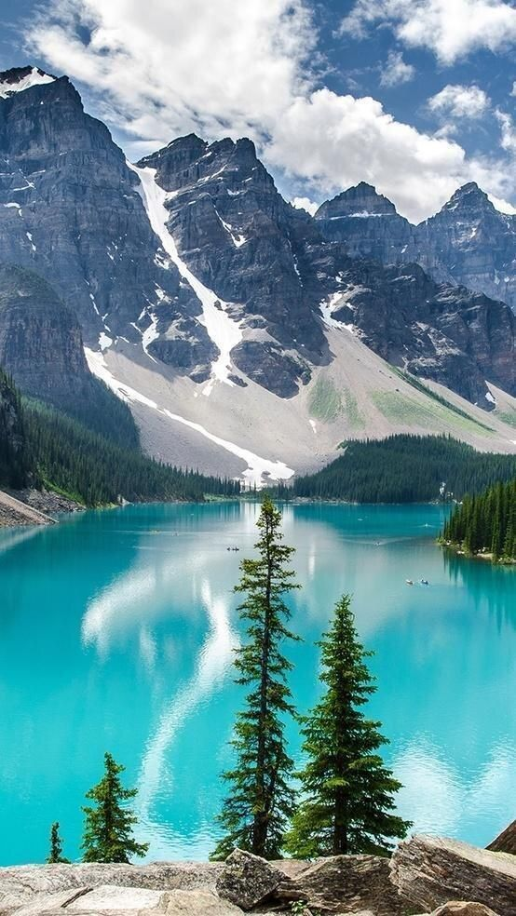

1️⃣ a turquoise lake in alberta, canada, in the style of natural symbolism, light white and dark aquamarine, clear edge definition, light gray and dark aquamarine, dark emerald and light azure --ar 23:41

2️⃣ a mountain surrounded by the blue water of a lake, in the style of teal and silver, iconic, cottagecore, hikecore, joyful celebration of nature --ar 23:41

3️⃣ this lake is a blue greenish lake surrounded by mountains, in the style of light turquoise and dark white, clear edge definition, light teal and dark maroon, the vancouver school, natural symbolism, joyful celebration of nature, y2k aesthetic --ar 23:41

4️⃣ bridal veil lake on the edge of a mountain surrounded by cliffs, in the style of turquoise and aquamarine, y2k aesthetic, cabincore, patrick brown, anglocore, environmental awareness, harmony with nature --ar 23:41

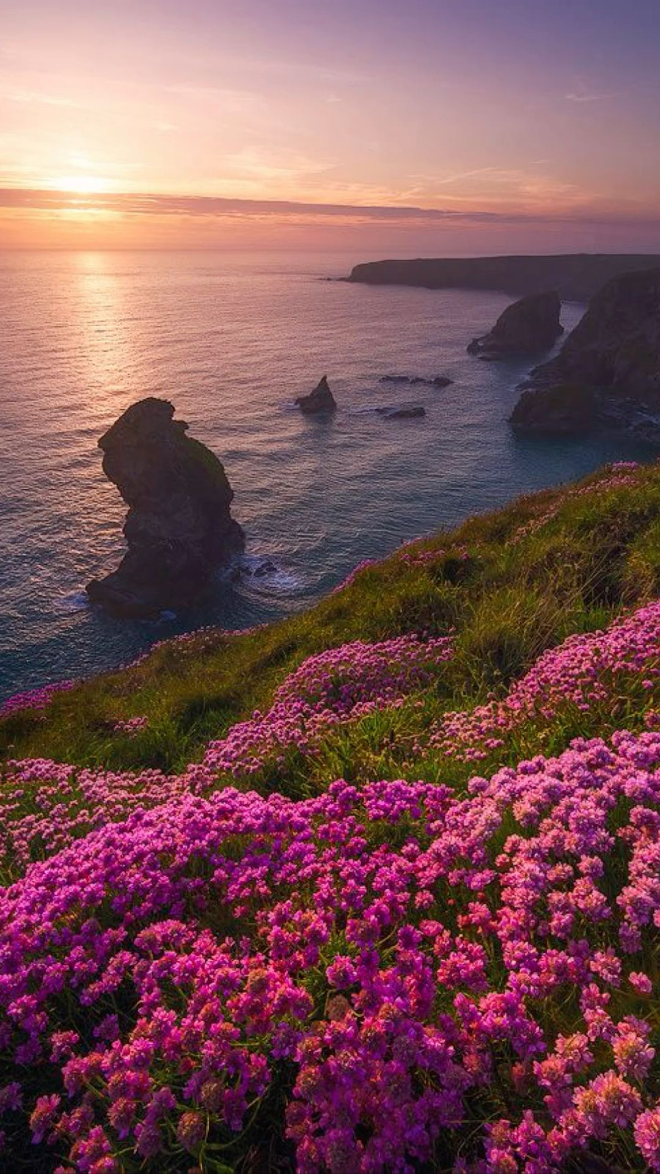

1️⃣ pink flowers bloom on the cliffs near the ocean, in the style of tj drysdale, traditional british landscapes, thomas heatherwick, uhd image, armand guillaumin, violet and emerald, rtx on --ar 9:16

2️⃣ pink flowers are visible on a hillside overlooking the ocean, in the style of ultraviolet photography, british topographical, rtx on, golden light, i can't believe how beautiful this is, bunnycore, iconic --ar 9:16

3️⃣ pink pink flowers in the water in north Cornwall, in the style of epic landscapes, light bronze and purple, bunnycore, i can't believe how beautiful this is, monumental vistas, birds-eye-view, rtx on --ar 9:16

4️⃣ sunrise over coves in the north of cornwall by alexie ainsley, in the style of floral explosions, magenta and bronze, filip hodas, tj drysdale, charles spencelayh, monumental vistas, land art --ar 9:16